C Sharp Enterprise Zone

Introduction
This book covers Enterprise application architecture, design and development using C#. The Habanero framework is referenced throughout the book as a sample of an application framework that implements a solution to the common problems experienced in Enterprise applications. In its broadest sense Enterprise applications create, store and manage information in Enterprises. In simple terms an enterprise application is not an operating system, a compiler an mp3 player, or a game. Enterprise applications are applications used in the running of a business where the information is stored in a structred manner over a long period of time (usually Relational databases). The information is usually shared between multiple users and is frequently used in geographically distributed locations. Examples are Customer Order Management, Procurement, Asset Management, Financial, Planning scheduling, logistical and supply chain management.\

Habanero is a framework for developing Enterprise applications. In essence Habanero solves the problems common to developing and maintaining enterprise applications.

This book is structured so that it can be used by junior developers as well as senior developers. The book assumes you have a reasonable knowledge of object oriented programming and practices, C#, DotNet and database management systems. The book also assumes that you have some knowledge of Enterprise application development. It is impossible for one book to cover in sufficient depth all the topics relating to the development of an enterprise application. We have therefore referenced other books, articles etc for those who are interested or require more detail. Having said this we will cover all the relevant topics in sufficient detail to provide the reader with the knowledge required to develop robust scalable enterprise applications while dodging the common mistakes.
This book covers all aspects of Enterprise application development including User interface development, Domain modelling, business rule implementation, object relational mapping and reporting.

The Habanero application development framework
Habanero has been developed over eight years and adapted to various technologies and development platforms. The architecture was developed by a company that specialises in Custom application development. Due to the nature of this business the applications had to be robust, easily extendable, easily deployed, secure, scalable from a single user to thousands of users, easily maintainable by any developer in the company or developers in the customer’s company. The framework had to be easily used while retaining extensibility, since developer skills ranged from young graduates to seasoned professionals and project sizes ranged from 2 weeks for a single developer to 3 years with a large team of developers.

As an additional advantage, this framework and access to its accumulated knowledge is available to Dot Net developers as free open source, allowing developers to review, study and contribute to it.

Firestarter
Firestarter is an application modelling and code generation tool. To maximise productivity and eliminate repetitive tasks Chillisoft developed Firestarter. This tool allows you to reverse engineer an existing database into an object model as well as to generate your classes, properties, relationships, CRUD user interfaces, business rules and basic unit tests. Firestarter is included for free with Habanero.

Why this book
As the Habanero development community has continued to grow, it has become clear that there is a need to provide a more extensive guide to the use of Habanero. We have therefore developed a full length book to provide developers with additional information not only on how to use Habanero and Firestarter but also on the common problems and solutions related to the development of Enterprise applications. This book will form the ideal guide book for developers new to Habanero and Enterprise applications or to developers with previous Habanero or Enterprise application experience.

Layout of the book
This can be used in many ways.
To help you determine how to read this book we have divided readers into two extremes. Most likely you will fit somewhere in between these:
- A developer who wants to know how to use Habanero framework to develop an application.
- A developer who wants to understand why and how the framework was developed, how to extend it and or how to use the concepts to develop their enterprise applications.
We understand that the readers of this book and the users of Habanero are busy. We have therefore tried in every way to ensure that the book can be used to provide immediate benefit at each stage. Since software developers learn best by example we have included extensive examples as well as a worked example that will be developed throughout the various sections of the book.

Section - Overview1:
This section provides the generation of a sample application using habanero and introduces all the principles required for developing enterprise applications. We would suggest that all readers read these chapters.

Chapter 1 covers the use of Habanero and Firestarter (an application code generator specialised for Habanero). This is very brief and used merely to give the reader a quick overview of the Framework.

Chapter 2 covers the principles and practices of Enterprise application development. This chapter will touch on all the concepts that will be covered in the remaining chapters of the book.

Section 2 – Business Logic Layer:
This section covers the development of the Business logic layer of an enterprise application, also called the domain model. The domain model involves a group of objects that model the area of the business that your system is implementing. The domain model in the simplest case closely resembles the relational database model but in more complex business scenarios can be significantly different. The domain model provides the layer where you model the domain behavior, data, validation and object relationships. One of the important functions of this layer is to hide the database, so this section will not discuss any database and object persistence issues. Object persistence will be addressed in Section 4.
Each chapter in the section starts with a brief introduction to the topic. This is followed by an example of how to model this using Firestarter and Habanero and how to use this in an application. A developer merely wanting to use Habanero can stop at this point and move onto the next chapter. (TODO ICON for each section)
The chapter will then delve into the more advanced features of Habanero and Enterprise applications including how Habanero implements these features, the design decisions behind the implementation and where relevant a discussion of why these decisions were made when compared to alternates.
Finally the chapter move onto how these features of Habanero can be extended to deal exceptional situations and requirements.

Section 3 - Presentation:
This section covers the development of the Presentation layer. The Presentation layer covers user interfaces for capturing, searching, manipulating, reporting on and viewing objects. The technologies covered here include, ASP, C# and Visual WebGui (an AJAX framework for web development). The reporting tool preferred is Active reports.

Section 4 - Data Access:
This section covers the development of the Data layer i.e. the mapping of business objects to a data store. This section includes persisting objects to XML, memory caches, object data stores and relational databases. Since most enterprise applications persist their data to relational databases, a large part of this section revolves around persisting objects in a relational database (using object relational mapping).
The structure of these chapters is the same as section 2 and should be used in the same manner.

Section 5 - Miscelaneous:
In addition to the presentation of Domain objects in a user interface, our business objects also may need to be available to other applications e.g via webservices. In this section we will show various solutions for these.

The book:
This book has been written by
Eric Savage
Peter Wiles
Brett Powell
Soriya Das
Hagashen Painintheass
Sherwin AnotherPain
Mark Whitfeld
Stuart Wiener

This book is provided free for use to the Habanero community under …….Creative Commons
If you wish to contribute then please post errata suggestions etc to …….
If you find this book useful and wish to make a financial contribution then please contribute to …. A charity for the orphans of AIDS.

Section 1 – Overview:

Chapter 1:
In t
Start with Simple Sample Application.
-- Require Firestarter can generate a fully functional UI Layer.

In this chapter we will cover a very simple sample application. This sample application is merely to demonstrate the power and speed of use of Habanero and Firestarter. In Section 2 to 4 a more realistic application will be developed.
Chapter 2:
Enterprise applications:
- Typically involve object persistence (often for very long periods of time).
- Will usually be subject to significant changes over their life cycle as the business adapts current business processes and implements new processes.
- Will usually involve many concurrent users.
- Have many user interfaces for capturing, viewing and organizing data.
- Produce and maintain data that is used extensively for business analysis and reporting.
- Often integrate with other enterprise applications.
- Are affected by all the political and business decisions that are made and need to be supported. Business systems will therefore often refuse to be standardized according to a software developer’s logic.
If you want a more detailed description of enterprise applications, the problems presented and common solutions then refer to Patterns of Enterprise Application Architecture by Martin Fowler which is in our opinion one of the best books on this topic

Habanero
Principles driving the development of the Habanero Architecture
Automate the tasks common to programming and enterprise application. Make the difficult programming tasks easy and the complex tasks doable.
Dry (Do not repeat).
Objectives of the framework.
Maximise Coherence, Minimise Coupling, Eliminate Duplication.
Work equally well for Web (ASP), Web (AJAX enabled) and Windows application. Providing a responsive interface required for windows applications and providing a postback response interface required for Web (ASP) while suffering no performance loss for due to the additional capabilities provided for Windows application.
Provide a Business object framework that allows the UI/Application developer a natural programming experience where the complexities of … are hidden

A Layered architecture. For the time being we will be discussing the logical architecture. The logical architecture separates the architecture into its layers based on a logical separation of responsibilities. The physical architecture relates to the actual physical deployment of the software i.e. which computers the various components are deployed onto. The logical architecture is thus independent of the physical architecture. It is important that a layered architecture is implemented regardless of the physical architecture. The reasons for this are numerous and most of them come back to the separation of responsibility. Traditionally application architectures have been separated into 3 layers.

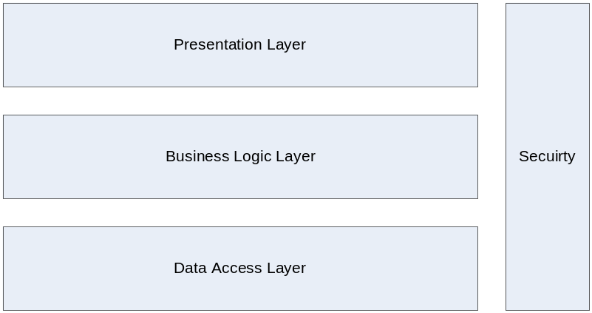
Figure 1: The Traditional 3 layers architecture.

- Presentation Layer (UI Layer)
The presentation layer is solely responsible for the communication with the user, which is typically via forms and reports. Although we think of the presentation layer as primarily relating to Graphical intefaces the presentation layer of an application would include webservices that you publish, command line calls, batch processing interfaces etc. There should be no business logic in the presentation layer due to the fact that it is difficult to test via automated tests and maintain in this layer. The presentation layer layer handles the user interface presentation and navigation. From this it can be seen that the presentation layer can actually be subdivided into two layers. The Presentation layer follows the MVP pattern (TODO: Reference Pattern) with a passive view, which means that the views (the top UI layer) are managed and directed by the presentation layer. The presenters are responsible for giving the views their data, pulling data from the views to be saved in the lower layers, and in general for responding to events raised by the views.
- Business logic layer (Domain Model layer)
The business logic layer is the layer where all business/domain specific logic resides. The business logic contains
  - The static rules and Business Object model, which contain the Entities of concern in the business domain (Business Objects/Entity Objects), the rules for how these objects relate to each other, the properties, the behaviour and the validation rules for the object (e.g. what properties are compulsory).
  - The dynamic and business process rules used to process logic in the business (e.g. the rules for how an order is processed through order entry).
- Data Storage Layer (Persistence Layer or Data Access layer).
This layer traditionally consists of the actual Data store (e.g. a relational database) and the retrieving and updating of the Business Objects from the Data Store. This layer can also be divided into two parts: Data Storage and object persistence. Data Storage involves the actual physical storage and management of data using SQL Server, Oracle, XML, WebServices, while object persistence refers to the synchronisation of the Business Objects’ state to the datastore.

For our purposes the traditional 3 layered architecture will be further broken down and will include the datastore thus providing us with 6 layers.
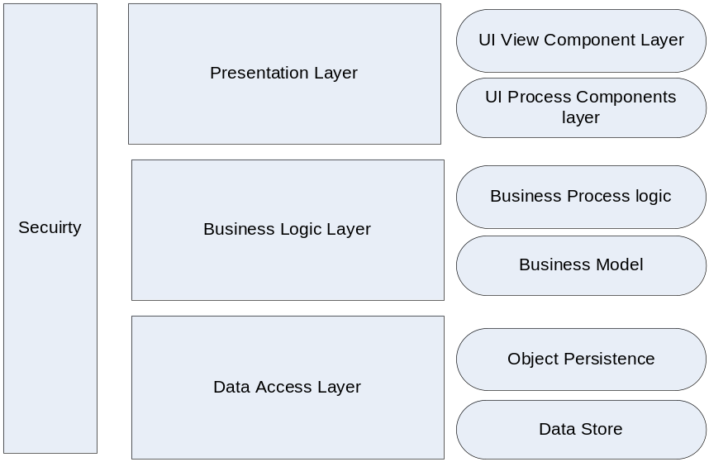
Figure 2: The traditional 3 layered architecture further subdivided.

The UI/Presentation Layer
The separation of the Presentation layer into a UI View layer and a UI Process layer may not be immediately obvious to Windows developers but to a web developer it is more obvious,
- The UI View Layer would be the web browser, style sheets, javascript etc .
- The UI Process layer is all the logic related to mapping business object data to controls, handling UI Events etc.

Business Logic Layer (Domain model + Application logic)
1) The business process layer. This layer is used to manage process logic. For instance, for the process of order entry the user must select the customer, select a product and enter a quantity. At this point the system will do a credit check. If the credit check passes, the order entry capture may continue, otherwise the order will be placed on hold and forwarded to a senior manager for approval. This layer is often called the workflow layer or the application logic layer. This layer is only required where complex process logic (workflow logic) exists.
2) The other type of business logic that is modelled in the business logic layer is the static model of the business. The static model consists of
- The classes of concern in the problem domain and the relationship between these classes e.g. an order will reference one customer and will consist of one or more order items.
- The rules for a class e.g. an order with order items cannot be deleted.
- The properties of an order e.g. an order has an order number, order date and expected delivery date.
- The property rules for the properties of a class e.g.
  - An order number and order date are compulsory. When an order is captured the order date must be less than today and within the last 2 months.
  - The order number and order date cannot be edited once the order has been persisted.
  - The expected delivery date cannot be captured for a new order.
Many applications and architectures implement these two sub layers in one layer. It is however better to separate them out for the simple reason that the business process layer is likely to be subject to relatively frequent change whereas the static business model is usually subject to significantly less change. For this reason they should be separated so as to isolate the changes and simplify change management.

Data Storage Layer (Persistance Layer)
The data storage layer is the architectural layer that is related to the storage and retrieval of business objects.
The business objects may be stored in multiple formats e.g. Relational databases, Files, XML Files, Object databases or Web Services. Regardless of the data storage mechanism, the business objects typically require the ability to Create, Read, Update and Delete (CRUD) themselves from the data store. A single system may in fact have business objects from multiple datastores.

The Data Storage Layer of the architecture is therefore also logically divided into two parts.
- The actual physical storage and retrieval of the data. In the case of storage in a relational database the data will be stored using a relational database management system (RDBMS, e.g. MySQL, Firebird, MS SQL and Oracle). This object data is retrieved and stored in the data store via the use of either SQL or stored procedures. The physical storage of the data thus forms one sub layer.
- In Dot Net any data retrieved from a relational data base is typically read into an ADO.Net dataset or data reader. The relevant data from this dataset is then used by the Business Objects e.g. Order and order item.

Differentiating between the presentation layer and the domain layer. It is often difficult to differentiate between these two layers since they interact strongly to provide the user with their total experience. The guideline we use is that if you are developing a Web Application, any logic that would be duplicated when replacing this with a windows application should be in the domain layer.

Object Modelling objects about behaviour i.e. non duplication of code. Relational modeling about data i.e. non duplication of data. This can often result in a mismatch between the data model and the object model. This is commonly known as the object relational impedence or mismatch. By using the various patterns proposed in …. Enterprise architecture book? And allowing the modeling of these this mismatch can be eliminated.
Upgrading and integrating with legacy systems where the existing database(s) may have design flaws and cannot be redesigned. The architecture must allow the developer to implement his/her own ORM strategy for that object.
Generatability- Minimum number and size of templates, minimum code generation and duplication in templates. Principle if you have to duplicate then have a single store and generate the remainder.
Scaleable.
High performance.
Extendable
Testability.
Incremental implementation and total lifecycle management of the software solution.
Security and access control
Transactional support.
Concurrency control.
Duplicate object control
Business object Property rules
Custom and standard property rules – Standard rules. There are a number of standard rules that are applied in many situations e.g. a property is compulsory. In addition each data type will have a particular standard rules e.g. A string length min and max and pattern match. These are modeled and are therefore implemented with no code for the developer. The architecture also allows the capturing of custom rules e.g. A property value must be greater than another property value. These custom rules can easily be programmed and applied by inheriting from ..??
IDataErrorInfo – allow grid or error provider to automatically provide support for showing invalid data.
Undoable: the business object and each of its properties must have the capability to undo i.e. where the user makes edits to the business object and then chooses to cancel or closes the form and the user objects state must be cancelled.
Multiple datasources.

Frameworks:- A frameworks is a set of cooperating classes that make up a reusable design for a specific class of software. A framework provides architectural guidance by partitioning the design into abstract classes and defining their responsibilities and collaborations. A framework captures the design decisions that are common in the application domain and thus emphasis design as well as code reuse. A framework will usually include a set of concrete subclasses that can be used as is. A framework will usually implement many design patterns. In fact a framework can be viewed as an implementation of a system of design patterns.

Coupling
Modules (Classes/packages) should be as independent as possible. Coupling is therefore a measure of the level of dependency between two modules.

Cohesion
Degree to which modules instructions are functionally related to each other. Highly cohesive modules contain instructions that collectively work together to solve specific tasks. The goal is to ensure that the modules exhibit a high degree of cohesiveness.

Object oriented design axioms
Axiom 1:- independence maintain the independence of the components.
Axiom 2:- Information. Minimise the information content of the design.
Occams razor:- The best theory explains the known fact with the minimum amount of complexity and maximum simplicity and straightforwardness.

Corollaries:-
Corollary 1: Uncoupled design with less information content. Highly cohesive classes and components can reduce coupling because only the minimum amount of essential information need be passed between objects.
Corollary 2: Single Purpose each class/component/method must have a single, clearly defined purpose. If you cannot clearly define the purpose of the class etc in a few sentences then you probably have not achieved this.
Corollary 3: A Large number of simple classes.
Corollary 4: Strong mapping. There should be a strong mapping between the physical system and the logical design.
Corollary 5: Standardisation. Promote standardisation by promoting interchangeable components and promoting reuse of existing classes/components.
Corollary 6: Design with inheritance. Common behaviour should be abstracted to superclasses.
Corollary 7: Design with interfaces.

Tracking an objects state, IsDirty IsNew, IsValid etc.
Object analysis and modeling.
Relationships between classes
- Inheritance.
- 1:M referenced.
- Lookup lists.
- 1:M composite.
- M:M referenced.

BindingList why not using this for binding to forms and grids. System.ComponentModel.IEditableObject and System.ComponentModel.IDataErrorInfo.
Sorted views of collections. Rocky chapter 2 pg 87.
Command execution. Frequently the programmer tasks are related to updating and editing business objects. But there are also many times when the developer is required to execute a command or bulk task e.g. calculate depreciation at the end of each month. The execution of this type of command should be carried out in the logic layer. Where the logic layer acts on the business objects. In cases where the performance ?? move to a later section.

Defining Layers

User Inteface generalization and generation.
The generalization of the user interface is significantly more difficult than the generalization of the Business object layer. The reasons for this are that the flexibility and adaptability of the user interface design are in many cases what gives an application its uniqueness. Having said that we have found in our development that between 60 and 90% of a business application can be used from generated controls and forms. In addition to this the ability to rapidly produce an application with standardised generated forms contributes significantly to the ability to produce and useable system quickly as per the agile methodology.

MetaProgramming.

Resource localization for language independence: NNB there was a tool to do this see my brain add ins.

Reporting
DataAdaptor: Many reporting tools e.g. Crystal are still very much focused on the model of reading data directly from a database using SQL or stored procedures.
In some cases for performance reasons this is the correct approach. More frequently the approach of using SQL or stored procedures to retrieve and manipulate data directly results in duplication of logic (i.e. logic that is already tested and working in the business objects is duplicated in the report). Reports that cannot be tested using automated test tools such as NUnit. In these cases what the developer requires is the ability to produce the objects to a report. In these cases Active reports provides a better model for achieving this but if for whatever reasons another reporting tool such as crystal reports is used then a dataadaptor can be used the dataadaptor will provides the ability to transform a business object into a dataset. Which can be used as the datasource of a report. This cannot be used for large datasets but is usually preferred for most reports required. For a more complete discussion see reporting??

Section 2 – Business Logic Layer:
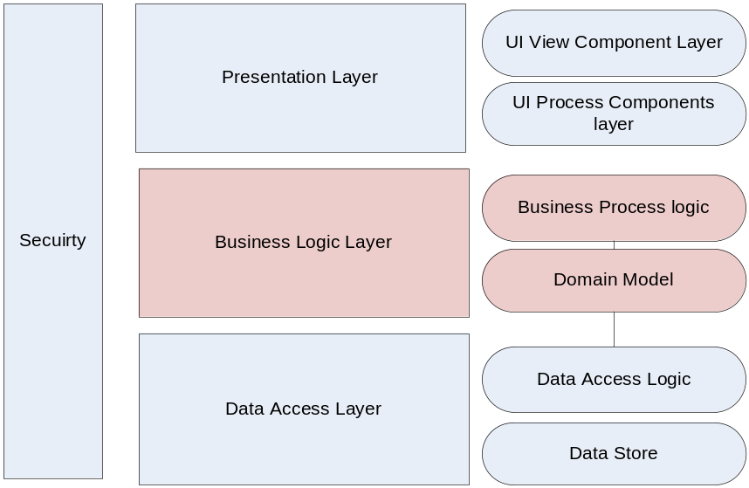
Business logic layer can usually be divided into two types.
The Business Domain layer/model has to do primarily with the static behaviour and their relationships to each other e.g. Contacts, orders, Order Approval strategies. This layer is the heart of business software. This layer maintains the State of the business e.g. the State of an Order and the rules involved in changing the state of the order. This layer interacts with the Data Access Layer to persist and retrieve these states over application instances.
Business Process logic layer also called the process logic, application logic, Application layer, service layer or workflow logic. This layer is kept very thin its primary responsibility is to delegate responsibility to a collaborating group of Business Objects to achieve a Use Case. The application logic covers things like notifying a senior manager if the order exceeds certain criteria, revenue recognizing all orders delivered for month. The Business Process Logic Layer does not contain business rules but instead is responsible for co-ordinating the Business objects as such this layer does not typically store or retrieve any long lived application state (state that persists between an application instance). The exception to this is where long lived workflow logic is stored i.e. where the state of the progress of a task is stored.

Perhaps this can be clarified by looking at a practical example from our order entry application.
Some typical static rules belonging in the domain model would be: customer can have many orders, an order can have only one customer, delivery date of a new order must be beyond the current date, or stock of an item can never fall below zero.
Examples of rules that fall in the process logic layer could be: to capture a new order, the customer must have sufficient credit and the order item must be linked to a current product. Clearly the latter is more approprate within the process flow of entering a new order and does not apply to the static state of a business object.

Why separate these layers: The Domain objects are less reusable across applications and modules if they contain substantial application logic. It is harder to implement application logic using a workflow application if the logic is mixed up with the domain model. By seperating the concerns it is easier to maintain and modify the application.
When to use a Business Process Logic Layer: It is sometimes difficult to decide when program logic belongs in the business domain layer and when in the business process layer. These guidelines are general rules of thumb but as you use these layers you will develop a feel for what belongs where. Also if you are using a good automated testing philosophy and refactoring it is relatively easy to move logic between these layers if it is in the incorrect place to start. As we develop examples through this book we will show examples of when we have separated the logic into these layers. Here we present a few brief guidelines on when to use business process objects:
- In our experience 60% - 80% of use cases in enterprise applications are simple CRUD use cases (create, read, update, delete data). In these cases there is no need for a Business Process logic layer. The User interface can simply create read, update and delete business objects.
- More complex use cases that have significant process flow, decision paths etc map naturally to business process logic operations. These interact with the various domain objects to implement the use case.
- In cases where transactions cross multiple objects e.g. capturing a new order results in updating the customer account, the planning system buckets, the available product and all these must be persisted in a single transaction, then it is essential to use a Business Process object.
- Complex logic such as messaging, integration to other applications and batch processes usually require a business process object.
- In cases where there are expected to be multiple interfaces to your application e.g. Web services, Rich client interface, Web interfaces, console interface.
- Functionality that has a strong relationship to a single business object and its composite children belongs in the business objects (in the domain layer).
- Functionality that does not have a strong relationship to a single business object belongs more naturally in the business process logic layer.

Discusss:- Rich domain model advantages and why even use on small projects. How benefit as project complexity grows and as project enhanced and modified. How works with agile methods of development. How domain model evolves as understanding between domain experts, analysts and developers evolves.

To follow the examples in this chapter you should have downloaded the Habanero Framework, Firestarter and the Examples (See Appendix A Setting up the Framework)

Chapter 3: The Domain Model – Business Objects
A good Business Domain model is at the heart of a well designed Enterprise application. This is why we start here. The mapping of the Rich Domain model to the Data Store, the implementation of complex use cases using the process logic layer and the development of the user interface layer will be discussed later in relation to the Domain model. Habanero provides the framework for developing, maintaining and refactoring a rich domain model. Firestarter provides a tool for rapidly implementing and managing the domain model in code.

Domain models and Domain Drive Design revolve around modelling Business Objects/Domain Objects and their relationships. We will therefore start with understanding a Business Object.

The Business Objects
There are many objects that collaborate in the implementation of any functionality in a well designed object oriented system. So what differentiates a Business Object from other objects in the system? A Business Object:
- Is an abstract representation of an entity or concept that exists in the business problem domain. E.g. An invoicing system will contain concepts such as Invoice, Invoice Line
- Has state that exists beyond the life cycle of a single instance of the application. I.e. a business object can be persisted or retrieved from a Data Store.
- Implements business rules related to the validation, editing and persisting of the business objects data.
- Doesn’t know how it will be used i.e. it can be used by a Windows Form, ASP or a web service.
- The Business Object encapsulates its data and implements business rules so that it protects the validity of its state independently of the client using it. I.e. if the business rule is that the Invoicing Date must be less than today, the Business Object will enforce this rule.
- The Business Object encapsulates any security rules relating to it. E.g. Only A user with Profile ‘Invoicing User’ can create a new invoice.
- Has behaviour. I.e. the business object implements functionality expected of the entity in the domain e.g. an invoice might have a method to Calculate Days Over Due for payment, Amount due for payment.
- A business object has Identity. The identity of a business object is an important issue since this provides the ability to persist and retrieve the business object from a Data Store. Ideally the Identity should be globally unique and immutable.

Example of a Business Object
Let’s take a look at how this is implemented in Habanero. We will start with a Business Object called Customer, and for now the only property the customer will have is customer name. The customer name is compulsory and must have a length greater than 5 characters and less than 100. For the purposes of explaining the use and functionality of the Customer Class we will be using Unit tests developed using the NUnit Framework. The Full Code for the Customer class and the Customer Test class used are available from the book downloads Chapter 3\Example1\ Customer.sln.
The FireStarter Project set up in Chapter 3\Example1\Customer.fsproj.
All the Customer object code is generated using Firestarter and is thus generated into the Customer.Def Partial Class.

In the Customer.Def.cs you will see the following implementation. The customer inherits from the BusinessObject Class. (following the Layer Supertype Pattern – Fowler - xxx).
public partial class Customer : BusinessObject
{

#region Properties
public virtual String CustomerName
{
get
{
return ((String)(base.GetPropertyValue("CustomerName")));
}
set
{
base.SetPropertyValue("CustomerName", value);
}
}

public virtual Guid? CustomerID
{
get
{
return ((Guid?)(base.GetPropertyValue("CustomerID")));
}
set
{
base.SetPropertyValue("CustomerID", value);
}
}
#endregion
}
As you can see this class contains two properties: the CustomerName and the object’s ID property CustomerID.

In addition to the Customer Class we have a ClassDefs.xml file. Although the application developer does not need to understand the details of this file, it is important to understand that it exists and what it does. The ClassDefs.xml assists Habanero in implementing the Meta-Data Mapping Pattern (See Fowler xxx) and Meta Programming paradigm.
In the ClassDefs.xml file you can see the class Customer is defined with its two properties CustomerName and CustomerID. CustomerID is defined as the PrimaryKey (Object ID).
<classes>
<class name="Customer" assembly="Customer.BO">
<property name="CustomerName" />
<property name="CustomerID" type="Guid" readWriteRule="WriteNew" displayName="CustomerID" />
<primaryKey>
<prop name="CustomerID" />
</primaryKey>
</class>
</classes>

Using the Customer Business Object
From here we are going to show the basics of how to use a Customer Business Object and what functionality and capability this provides to the application developer. Most of this functionality will be demonstrated using the appropriate unit tests in TestCreateCustomer.

Creating a new Customer
[Test]
public void TestCreateNewCustomer_NoPropertyRules()
{
//---------------Set up test pack-------------------

//---------------Assert Precondition----------------

//---------------Execute Test ----------------------
Customer customer = new Customer();
//---------------Test Result -----------------------
Assert.IsTrue(customer.Status.IsNew);
Assert.IsNotNull(customer.CustomerID);

Assert.IsFalse(customer.Status.IsDeleted);
Assert.IsFalse(customer.Status.IsDirty);
Assert.IsFalse(customer.Status.IsEditing);
Assert.IsTrue(customer.Status.IsValid());
}
From the above you can see that a new Business Object Customer is created with a status IsNew. Habanero has also already created an object ID for the Customer. The business object has not yet been edited and it’s IsDirty and IsEditing Status is therefore false. No rules have yet been set up for the Customer Business Object – its IsValid property is therefore true.

Creating a new Customer with CustomerName Compulsory
The Business rule that the customer name is compulsory is set in FireStarter along with the minimum (5 characters) and maximum length (100 characters) of the CustomerName.
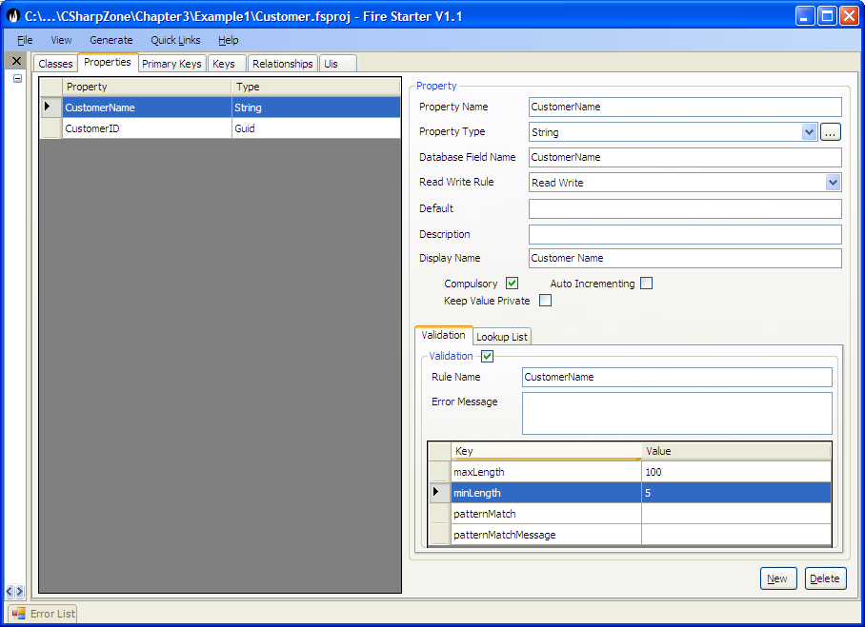

This does not in any way change the Customer.Def.cs but instead changes the metadata rules set up in the ClassDef.xml.
The Customer name property definition is modified to be:
<property name="CustomerName" compulsory="true">
<rule name="CustomerName">
<add key="maxLength" value="100" />
<add key="minLength" value="5" />
</rule>
</property>

The Habanero Framework implements the Customer Compulsory rule as demonstrated in the following tests.

[Test]
public void TestCreateNewCustomer_CustomerNameCompusory()
{
//--------------------------------------------------
//When a new customer is created it is created with
// broken rules for any
// compulsory properties that do not have a default value set
// (In this case Customer name).
//--------------------------------------------------
//---------------Set up test pack-------------------

//---------------Assert Precondition----------------

//---------------Execute Test ----------------------
Customer customer = new Customer();
//---------------Test Result -----------------------
Assert.IsTrue(customer.Status.IsNew);
Assert.IsNotNull(customer.CustomerID);

Assert.IsFalse(customer.Status.IsDeleted);
Assert.IsFalse(customer.Status.IsDirty);
Assert.IsFalse(customer.Status.IsEditing);
Assert.IsFalse(customer.Status.IsValid());
StringAssert.Contains("'Customer Name' is a compulsory field and has no value",
customer.Status.IsValidMessage);
}

Set Property Value
The Habanero Framework implements the CustomerNameRule as demonstrated in the following tests.
[Test]
public void TestNewCustomer_SetCustomerName_ToValidValue()
{
//When a property is set to a valid value for a compulsory field
// that has a broken rule the rule is set to no longer broken.
//---------------Set up test pack-------------------
Customer customer = new Customer();
//---------------Assert Precondition----------------
Assert.IsTrue(customer.Status.IsNew);
Assert.IsFalse(customer.Status.IsDirty);
Assert.IsFalse(customer.Status.IsEditing);
StringAssert.Contains("'Customer Name' is a compulsory field and has no value",
customer.Status.IsValidMessage);

//---------------Execute Test ----------------------
customer.CustomerName = "Valid Name";

//---------------Test Result -----------------------
Assert.IsTrue(customer.Status.IsDirty);
Assert.IsTrue(customer.Status.IsEditing);
Assert.AreEqual("", customer.Status.IsValidMessage);
}

The Test class contains some additional tests that demonstrate other variants of setting and getting property values, and examples of how setting property values changes the Customer Status based on the property rules.

Saving Business Objects
The implementation details of saving and loading Business objects from a DataStore are discussed in detail in section 4. For the purposes of this chapter we are just going to look at some methods to save a single object to a DataStore. The tests used in these examples are all from the TestSaveCustomer. From this test you can clearly see that a saved business object is no longer dirty and is no longer new. From the test Test_Save_Invalid_ValidCustomer you can see that a business object in an invalid state cannot be persisted and the error BusObjectInAnInvalidStateException will be thrown if the application tries.

[Test]
public void Test_SaveValidCustomer()
{
//---------------Set up test pack-------------------
Customer customer = new Customer();
customer.CustomerName = "Valid Name";
customer.CustomerCode = "Code";

//---------------Assert Precondition----------------
Assert.IsTrue(customer.Status.IsNew);
Assert.IsTrue(customer.Status.IsDirty);

//---------------Execute Test ----------------------
customer.Save();

//---------------Test Result -----------------------
Assert.IsFalse(customer.Status.IsNew);
Assert.IsFalse(customer.Status.IsDirty);
}
Test_Save_Invalid_ValidCustomer – do test in code

Using Property Read Write Rules
One of the other rules often implemented for a Business Object Property is a rule relating to the reading and writing of a Property depending on the status of the business object. For instance, a customer has a property CustomerCode whose value is used to integrate to the External systems. This property is compulsory and can never be changed once it has been set. We add this property to FireStarter with the ReadWrite Rule – WriteNew.
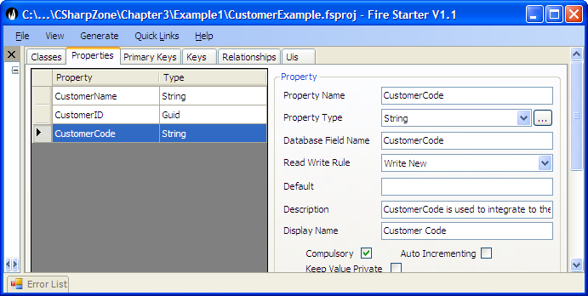

The other available read-write options are:
- Read Only – used when a properties value is loaded from a datastore but never updated to the business object e.g. if a stored procedure or external application updates this property’s value and it is only ever read from the datastore by the business object and can never be set, updated or persisted back.
- Read Write – The property’s value can be read and updated many times in the life of the Business Object. This is the default setting.
- Write New – The property’s value can only be set when the object is new (i.e. the business object has never previously been updated to a data store).
- Write Not New – A value can never be set if the business object is new. The value can be set any time that the business object is not new.
- Write Once – A value for a property can only be set to a business object once. This may be set at any stage of the business objects life but once the value for the property is set it can never be changed.

There are a few tests in the TestSetCustomerBOProp class relating ReadWriteRules but the most pertinent tests is this test which shows that the BusinessObjectReadWriteRuleException error is raised if the application attempts to update the Business Object property in contravention of its ReadWrite Rules. The details of how this is implemented are shown in Implementing Business Objects below

[Test]
public void Test_SetCustomerCode_ForPersistedCustomer()
{
//A WriteNew property can not be written to when the business object already persisted.
//---------------Set up test pack-------------------
Customer customer = CreateSavedCustomer();
IBOProp customerCodeBoProp = customer.Props["CustomerCode"];

//---------------Assert Precondition----------------
Assert.AreEqual(PropReadWriteRule.WriteNew, customerCodeBoProp.PropDef.ReadWriteRule);
Assert.IsFalse(customer.Status.IsNew);

//---------------Execute Test ----------------------
try
{
customer.CustomerCode = "Code New";
Assert.Fail("expected Err");
}
//---------------Test Result -----------------------
catch (BusinessObjectReadWriteRuleException ex)
{
StringAssert.Contains("Error writing to property 'Customer Code' because it is configured as a 'WriteNew' property", ex.Message);
}
}

Customer Lookup Rule
TODO: Needs section of using a lookup list for a property.

Deleting a Business Object
Deleting a Business Object is extremely simple. First the object is marked for deletion using customer.Delete(); and then the deletion is persisted to the DataStore using customer.Save(); The only thing to remember is that when a customer is set as Deleted this has not yet been persisted to the DataStore – only when the customer.Save() is called is the object actually deleted. This is implemented so as to allow objects marked for deletion to be added to a transaction along with other objects. (See Section 4: Data Access Layer -Transaction Committer).
[Test]
public void Test_DeleteCustomer()
{
//---------------Set up test pack-------------------
Customer customer = CreateSavedCustomer();
customer.Delete();

//---------------Assert Precondition----------------
Assert.IsFalse(customer.Status.IsNew);
Assert.IsTrue(customer.Status.IsDeleted);
Assert.IsTrue(customer.Status.IsDirty);

//---------------Execute Test ----------------------
customer.Save();

//---------------Test Result -----------------------
Assert.IsTrue(customer.Status.IsNew);
Assert.IsTrue(customer.Status.IsDeleted);
Assert.IsFalse(customer.Status.IsDirty);
}

Business Object Identity
Business Object Identity is an issue that mainly impacts the Data Access layer but it has important consequences in the Business Object Layer. For this reason we will briefly discuss it here (A more detailed discussion can be found in Section 4 – Data Access Layer). The managing and tracking of the Identity of an object is essential for any persistable Object (i.e. any object that persists its state beyond the life of a single instance of an application), since the object identity has to be used to retrieve the object from the external datastore. Since all Business Objects are persistable it is essential that the Business Objects implement a strategy for managing object identity.
Principles of Object Identity:
- Ideally an object identity should be immutable. An object identity that can be modified creates a set of problems for managing an application, particularly regarding concurrency issues For instance, User1 and user2 load the same object from the dataStore. User1 updates the object’s identity and persists it to the database. Then user2 edits some other properties on the object and updates it. The original object cannot be found in the datastore since its identity has been changed.
- The Object Identity should be a globally unique identifier. This ensures that business objects can be found and distributed while being identified by their identities alone independently of the application, class or type of object.
- Object Identity should have no meaning. The object should be identified and stored based on a value that has no meaning in the Business Domain. Properties such as ProductCode, should not serve as the Identifier of an object even if they are immutable. The reason is simply that at some point the ‘immutable’ value is going to be changed. Typically a user is going to type in the incorrect code and this is going to have to be edited or the organisation is going to modify the algorithm for generating ProductCode and when this happens the ProductCode will be changed.
- From the above we can conclude that the Business Object’s identity should not be a composite of more than one value e.g. Surname, Firstname should not be used to provide a composite identity.
From the above we can conclude that in the ideal case where we have control/influence over the database design we can implement these principles. Unfortunately we have found that there are many cases when these principles cannot be adhered to. A typical example is when rewriting an existing system where this system already has a database that cannot be changed. The Habanero Framework thus provides strategies whereby you can circumvent any of these object identity principles when developing an application. It is however important to point out that if you choose to use a mutable property for the object identity you should implement an appropriate concurrency control strategy for dealing with this. See Section 4 – Data Access Layer – Concurrency Control.

The Object Identity is modelled in FireStarter. The Object identity is always composed of one or more properties of the Business Object. Ideally you will be able to create a property (and field in the database) specifically for this purpose – in this example CustomerID property.
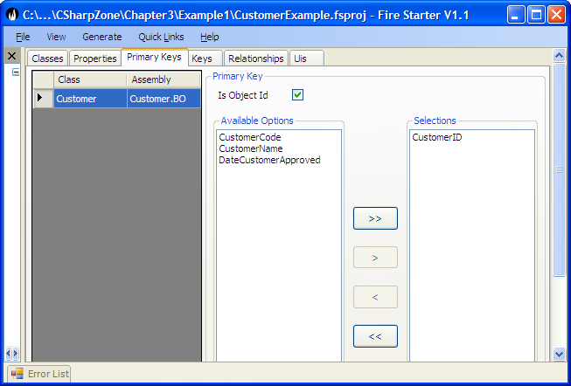

Loading a Business Object from the DataStore
In cases where the application knows the ID, the business object is easily retrieved from the DataStore. All object retrieval is carried out using the BusinessObjectLoader (BORegistry.DataAccessor.BusinessObjectLoader). The details involved in Loading Business Objects from a database are discussed in Detail in Section 4 – Data Access Layer.
[Test]
public void Test_LoadCustomerUsingID()
{
///This test shows that if a persisted object is loaded from the
/// dataStore using the BusinessObjectLoader.GetBusinessObject.
/// Then an object with the exact same status and data as
/// the persisted object is loaded.
//---------------Set up test pack-------------------
Customer customer = CreateSavedCustomer();

//---------------Assert Precondition----------------
Assert.IsFalse(customer.Status.IsDirty);
Assert.IsFalse(customer.Status.IsNew);
Assert.IsTrue(customer.Status.IsValid());

//---------------Execute Test ----------------------
Customer customer2 = GetBusinessObjectLoader().GetBusinessObject<Customer>(customer.ID);

//---------------Test Result -----------------------
Assert.IsFalse(customer2.Status.IsDirty);
Assert.IsFalse(customer2.Status.IsNew);
Assert.IsTrue(customer2.Status.IsValid());

Assert.AreEqual(customer2.CustomerCode, customer.CustomerCode);
Assert.AreEqual(customer2.CustomerName, customer.CustomerName);
Assert.AreEqual(customer2.CustomerID, customer.CustomerID);
Assert.AreSame(customer, customer2);
}

It is important to note that in cases such as this where a reference to the original customer is still being held by the application the second customer returned by the BusinessObjectLoader (i.e. customer2) is in fact the exact same object as the original customer i.e. Assert.AreSame(customer, customer2). The implementation of this will be discussed in Implementing Business Objects Loading below.

You can also retrieve a business object from the BusinessObjectLoader using a criteria (e.g. CustomerCode = ‘HO13787’) this will more frequently be used when loading a collection of Business Objects but can also be used when loading a particular Business Object. Once again the test shows that exactly the same instance of the customer is returned by the BusinessObjectLoader.

[Test]
public void Test_LoadCustomerUsingStringCriteria()
{
///This test shows that if a persisted object is loaded from the
/// dataStore using the BusinessObjectLoader.GetBusinessObject.
/// Then an object with the exact same status and data as
/// the persisted object is loaded.
//---------------Set up test pack-------------------
Customer customer = CreateSavedCustomer();

//---------------Assert Precondition----------------
Assert.IsFalse(customer.Status.IsNew);

//---------------Execute Test ----------------------
string loadCriteria = "CustomerCode = " + customer.CustomerCode;
Customer customer2 =
GetBusinessObjectLoader().GetBusinessObject<Customer>(loadCriteria);

//---------------Test Result -----------------------
Assert.IsFalse(customer2.Status.IsNew);
Assert.AreSame(customer, customer2);
}

The Criteria objects and criteria strings are much more powerful than shown so far and include all the normal operators required i.e. AND, OR, opening and closing brackets, <>, =, <>, >=, <=, >, <, IS NOT, IS, NOT LIKE, LIKE.
Note:
- If you try loading an individual object (GetBusinessObject) with a Criteria and more than one matching object is found in the database an error will be raised.
- The CustomerCode is the Business Object’s property name and not the database field name. This is very important since by working only with the domain model the application developer is totally insulated from the database. The Habanero Framework interprets the property name into the appropriate field name when querying the datastore.

Once the object is loaded it can be refreshed multiple times from the database. An object that is currently being edited (customer2.Status.IsDirty == true) may not be refreshed but a Business Object that is not dirty can be refreshed. This is very useful when you are about to carry out a calculation and want to ensure that you have the latest version of the object (i.e. Another user may have edited the object since you loaded it). For more detail on concurrency control see Section 4 – Data Access Layer – Concurrency Control.

The object is refreshed using the GetBusinessObjectLoader().Refresh(customer) method.

Cancelling Edits on an object
If the application or user has made an error then edits (changes to the object not yet persisted to the datastore) can be cancelled using the Restore Method on the business object.

For restoring a new business object see Test_RestoreNewCustomer.

The more interesting test however is retrieving an object from the DataStore, editing it and then restoring it as shown in Test_RestoreLoadedCustomer

[Test]
public void Test_RestoreLoadedCustomer()
{
//Tests Restoring a loaded business object.
// This test shows that when the customer's Restore
// method is called. The customers Status and Data is
// restored so as to be the same as an object just loaded
// from the DataStore.
//---------------Set up test pack-------------------
Customer customer = CreateSavedCustomer();
string origCustomerName = customer.CustomerName;
customer.CustomerName = "New customer Name";

//---------------Assert Precondition----------------
Assert.IsTrue(customer.Status.IsDirty);
Assert.AreNotEqual(origCustomerName, customer.CustomerName);

//---------------Execute Test ----------------------
customer.Restore();

//---------------Test Result -----------------------
Assert.IsFalse(customer.Status.IsDirty);
Assert.AreEqual(origCustomerName, customer.CustomerName);
}

Alternate Key for a Business Object
It is possible for a business object to have one or more Alternate Keys. An alternate Key could be composite or simple. The Alternate key identifies one or more properties which together act as a rule preventing a duplicate business object from being persisted. A classical example of an Alternate Key for the customer is where the customer code must be unique (i.e. two customers with the same code cannot exist in the DataStore),

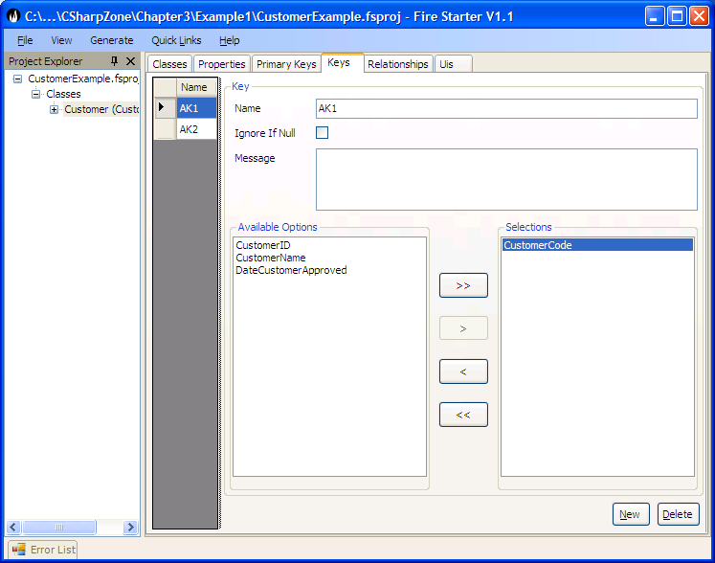

TODO: Reference test example code

Implementing Business Objects
Do something to explain this is advanced knowledge not required by most application developers.

When an application using Habanero is started it loads the appropriate ClassDefs.xml (we will go into detail of where and when this happens in Section 5 – UI Layer). The ClassDefs are loaded into the class ClassDef which contains a static collection of the class definitions for each Business Object defined in the ClassDefs.xml.

Creating a new Business Object
When a Business Object of type Customer is created the BusinessObject is constructed with its BOStatus appropriately set as new, not deleted and not dirty.
The business object properties and any related rules are retrieved for the Customer Business Object from the ClassDef class. From these class definitions a collection (BOPropCol) of Business Object properties (BOProp) is created for the customer. Each business object property tracks the current value for the Business object property, whether the property is dirty, valid etc. The BOProp also contains a reference to the definition for the Property i.e. The PropDef.

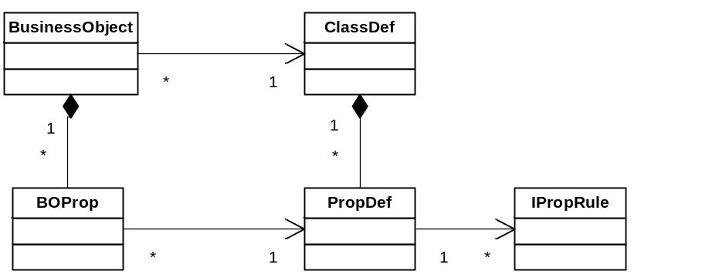
Figure 3.1: The relationship between a Business object instance and its definitions.

The above class diagram represents a pattern that is used throughout the framework and therefore warrants some discussion and explanation. The ClassDef and its related PropDefs are loaded from the ClassDefs.xml.
The ClassDef and PropDef classes contain the definitions of a class and its properties for a particular BusinessObject type e.g. Customer. The definition classes ClassDef and PropDef contain the definitions that are common to all instances of the Customer.
The BOProp contains only the data that is unique for a particular instance of the Business Object i.e. CustomerX.
For instance with CustomerName, the PropDef defines that its type is a string and defines the PropertyRules associated with this property, while the BOProp for CustomerName will store the actual value for that instance of Customer.

Set Property Value
Let’s demonstrate this with some tests by referring to the TestSetCustomerBOProp class. Note that the Application Developer would never user BOProp directly (The previous examples of setting and getting properties should always be used).
These tests are shown here purely to demonstrate how the framework implements Business Objects and their properties.

[Test]
public void Test_SetCustomerName_ToInvalidValidValue_FromValidValue()
{
//When a property is set to an In Valid Value for a compulsory field
// that has no value the broken rule is changed from compulsory to
// Invalid Value.
//---------------Set up test pack-------------------
Customer customer = new Customer();
IBOProp customerNameBoProp = customer.Props["CustomerName"];
customer.CustomerName = "Valid Name";

//---------------Assert Precondition----------------
Assert.AreEqual("Valid Name", customerNameBoProp.Value);
Assert.IsTrue(customerNameBoProp.IsValid);
Assert.AreEqual("", customerNameBoProp.InvalidReason);

//---------------Execute Test ----------------------
customer.CustomerName = "Inv";

//---------------Test Result -----------------------
Assert.AreEqual("Inv", customerNameBoProp.Value);
Assert.IsFalse(customerNameBoProp.IsValid);
StringAssert.Contains("'Inv' for property 'Customer Name' is not valid for the rule 'CustomerName'. The length cannot be less than 5 character", customerNameBoProp.InvalidReason);
}

From this test you can see that the BOProp tracks its current value (Value) as well as its Status (IsDirty, IsValid) and any invalid reasons. The Business Objects Status is then derived from the composite status of all its BOProps.

Implementing Property Rules
Property Rules are implemented using a Strategy Pattern (See GOF). This pattern allows the application developer to easily extend the Framework by adding new rule types and creating custom Property Rules for the application. (See Extending the Habanero Framework).
The property rules are implemented in such a way that they are available to the user interface allowing for the development of responsive applications with no duplication of rules.

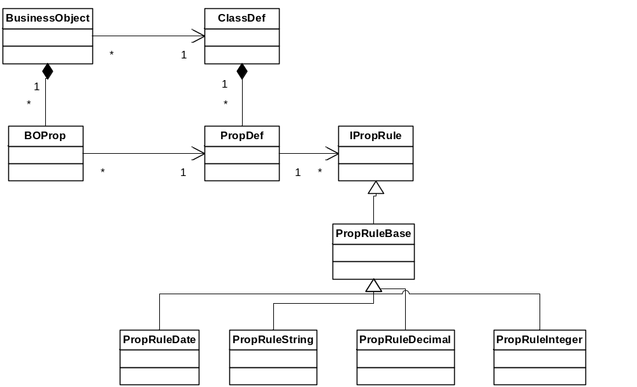
Figure 3.3: The relationship between the Business Object properties and its property rules.

Implementing Saving Business Object to DataStore
The details of how an object is saved to the data store are discussed in Detail in Section 4. For the purposes of this chapter we are only going to look at how the Business Objects Properties are updated when the object is saved. This test demonstrates how the business object property is updated.
The BOProp has two values the Value and the PersistedPropertyValue. The Value always holds the current value for that BOProp whereas the PersistedPropertyValue holds the value of the propery as currently held in the datastore. As you can see from this test a new Customer’s BOProps have no PersistedPropertyValue. Once the Business Object has been saved to the Datastore the PersistedPropertValue is updated with the Value.
[Test]
public void Test_SaveBOProp()
{
//Testing that when a customer is saved the Persisted Property
// Value is updated to the PropertyValue
//---------------Set up test pack-------------------
Customer customer = new Customer();
const string newCustomerName = "Valid Name";
customer.CustomerName = newCustomerName;
customer.CustomerCode = "Code";
IBOProp customerNameProp = customer.Props["CustomerName"];

//---------------Assert Precondition----------------
Assert.IsNull(customerNameProp.PersistedPropertyValue, "A new object should not have a persisted value");
Assert.AreEqual(newCustomerName, customerNameProp.Value);

//---------------Execute Test ----------------------
customer.Save();

//---------------Test Result -----------------------
Assert.AreEqual(newCustomerName, customerNameProp.Value);
Assert.AreEqual(newCustomerName, customerNameProp.PersistedPropertyValue,
"After saving the PersistedPropertyValue should be backed up to the property value");
}

Implementing Business Object Identity
The Business Object identity is implemented in a highly flexible yet simple manner in Habanero. The implementation follows the Identity Field Pattern (Fowler - 216). The Object identity (PrimaryKey) is defined as consisting of One or More Properties (BOProp) of the Business Object. The ClassDef for the customer will be loaded with a PrimaryKeyDef. The PrimarKeyDef will be loaded with the PropDef(s) that make up its primary key (in this case the CustomerID). When the Customer Object is created the Customer Object is created with a BOPrimaryKey that references the CustomerID BOProp (The BOPrimaryKey is thus merely a collection of BOProps). At any point that the user requests the ID the BOPrimaryKey Object will be returned.

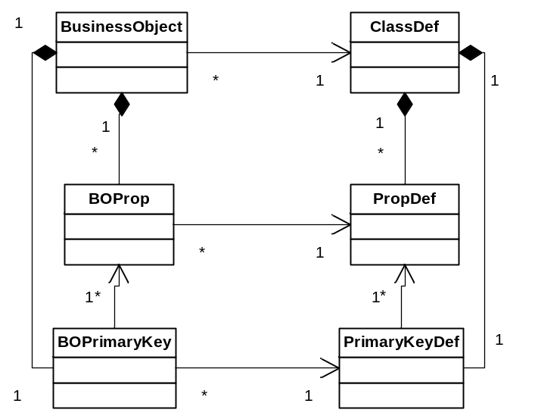
Figure 3.2: The relationship between a Business object instance and its primary key definition.

From this test you can see that the PrimaryKeyDef is created with a single PropDef and that the BOPrimaryKey is created with a reference to the BOProp for CustomerID property. See the TestBusinessObjectIdentity class.
[Test]
public void Test_CreateCustomerWithIdentity()
{
//This test shows the that the PrimaryKeyDef and BOPrimaryKey
// are set up according to the class definition defined for
// customer. It also shows that the CustomerID is automatically
// set to a new GUID Value.

//---------------Execute Test ----------------------
Customer customer = new Customer();

//---------------Test Result -----------------------
ClassDef customerClassDef = customer.ClassDef;
PrimaryKeyDef primaryKeyDef = customerClassDef.PrimaryKeyDef;
Assert.AreEqual(1, primaryKeyDef.Count);

IPrimaryKey customerPrimaryKey = customer.ID;
Assert.AreEqual(1, customerPrimaryKey.Count);
Assert.IsTrue(customerPrimaryKey.Contains("CustomerID"));
IBOProp customerIDBOProp = customerPrimaryKey["CustomerID"];

Assert.IsNotNull(customerIDBOProp, "Since the CustomerID is an object id it should be set to a value");
}
In the TestBusinessObjectIdentity class we also have the example Test_CreateBO_WithNonGuidID of creating an object that does not use a Guid Object ID. This Test is interesting in that it also shows how a BusinessObject can be defined directly in code without the use of ClassDefs.xml. We do not go into the details of defining BusinessObjects programmatically in the book – if you are interested look at the test and its BusinessObject.
If you are using a non Guid Object identifier the following should be remembered:
- All properties that are part of the PrimaryKey should be Compulsory and WriteNew (Properties cannot be null and cannot be changed once the business object has been persisted).
- If you are using your own Number Generator to generate a unique identifier for the Business Object then you should refer to Extending the Habanero Framework.
- If the properties must be mutable (Changeable) then you should ensure that the modification of the ID can only be done via a separate business process that is well isolated and/or that only users with high level of authority can edit these properties. You should use concurrency control with pessimistic locking (see Section 4) when editing a primary key ensure that no concurrency control conflicts occur.

Implementing Alternate Keys
Alternate keys are implemented in an almost identical manner to Primary Keys. In fact the BOPrimaryKey inherits from BOKey and PrimaryKeyDef inherits from KeyDef. The difference is in the relationship to the Business Object whereas a Business Object can have only one primary key it can have many alternate keys. As with the primary key the BOKey can be composite or single. The uniqueness of the alternate key is only verified when trying to persist the object to the database. The alternate key can be mutable or immutable as required by the business rules.
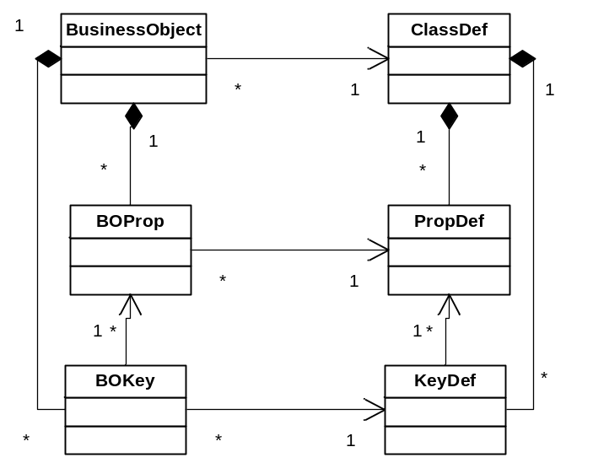
Figure 3.4: The relationship between a Business object instance and its alternate key definitions.

The Business Object Manager
It is essential when developing Enterprise applications that a single business object is never represented by two instances of the same business object in the same application instance. The reasons for this essentially revolve around concurrency control issues. Imagine that a user loads one instance of Customer X via one user interface, then the same user loads a second instance of Customer X and edits the second instance of Customer X. If the user now returns to the original user interface, the edited data will not be shown i.e. the user will see the old data even though they just edited the object. If you want more details on this issue then refer to the Identity Map Pattern - Fowler – 216.

To prevent this the Habanero Framework implements the Identity Map Pattern using the BusinessObjectManager Class.
The BusinessObjectManager is in essence a dictionary of Weak References to Business Objects. The weak references are keyed on the ObjectID. A weak reference is in essence a safe pointer to an object i.e. it is a reference to an object that does not prevent the object from being garbage collected.

There are no tests in CustomerExample for the BusinessObjectManager since most of its methods are internal but the Habanero.Test.BO project (which ships with the framework) contains the TestBusinessObjectManager Class that shows the behaviour of the object manager in detail.

In summary:
- When a new Business Object is first persisted it is added to the BusinessObjectManager.
- When a Business Object is retrieved (loaded from the datastore) for the first time then it is added to the BusinessObjectManager.
- When a Business Object that already exists in the BusinessObjectManager is retrieved, the already existing Business Object from the BusinessObjectManager is returned. (Note: there are various options for refreshing or not refreshing the already loaded business object that are covered in Section 4 – Data Access Layer).
- When a Business Object is collected by the garbage collector it is removed from the BusinessObjectManager.

Loading Business Object from DataStore
The details of mapping and loading a Business Object from a DataStore will be discussed in Section 4.
For this section we will look at how the BOProp is loaded with the appropriate data. When a Business Object is loaded from the datastore the BOProp’s PersistedPropertyValue and Value are loaded with the value currently held in the DataStore.

TODO: reference test

Summarising the Business Object
In summary the Business Object consists of a BOPrimaryKey and a collection of BOProperties. The BOProperties are responsible for maintaining their own state and for validating any business rules such as ReadWriteRules, Compulsory rules or IPropRules. The Business Object is constructed with the appropriate BOPrimaryKey and BOProps based on the ClassDefinition contained in the ClassDefs Collection.

The BOProp is validated using the Property Rules associated with its PropDef.

The advantages of having a Business Object made up of intelligent BOProps representing the Business Object’s Data instead of simple fields should already be becoming clear. The advantages will become even clearer when studying the UI Layer and the DataAccess layer. In preparation however we will briefly mention the following:
- The BOProp has the knowledge of whether the user is allowed to edit it. The appropriate user control can therefore be enabled or disabled appropriately.
- The BOProp has direct access to its property rules. The user interface can utilise these rules directly to do data input validation. This results in highly responsive user interfaces while still ensuring that the Business Objects enforce all their rules with no duplication of rules.
- The PropDef contains the required information on how it is mapped to any field in the DataStore allowing the application developer to load Business Objects without having to know the database table or field names.

Extending Business Object

Applying Security to Business Objects
Applying application security reliably is essential for any enterprise application. Security is a broad topic and covers many areas that are way beyond the scope of this book, having said that it is essential that security is applied appropriately to the Business Object Layer. Security Based Rules for accessing, deleting and editing Data is just as appropriate in the Business Object Layer as ReadWrite Rules, Compulsory Rule and Validation rules. In other words authorisation rules regarding which users can access which functions and data logically belong in the Business Object layer and the Business Objects should implement them where appropriate.

Security is one of the areas of application development that involves many decisions and is highly dependent on the Environment in which the application is being deployed. For this reason we do not directly include any Security Policy into the Business Object Layer but instead provide the Strategy (and thus the hooks) for the application developer to implement their own security Policy. We have also developed a security application that is independent of the Habanero Framework but which Implements a security policy that we have used on many applications and which also acts as an example of how to implement security within the Habanero Framework. We have also developed some security objects that implement these security policies (see ???).

To understand security we need to clearly differentiate between Authentication and Authorisation.
Authentication involves the verification that the user is who she says she is.
Authorisation involves determining whether the user is authorised to use a particular function (be that an application, a Business Object, a Business Object Property, a user interface or a report).

Authentication: There are essentially two security options:
- Integrated Authentication: Use Windows Integrated Security i.e. use the Windows user who is currently logged onto the windows operating system as the Authenticated User.
- Custom Authentication: Custom application is used for logging users into the application or into a set of applications. The logged on user as per the application could be different from the logged on user as per Windows.
The Habanero Framework Supports the user of both Integrated Authentication and Custom Authentication. Authentication will be discussed in more detail under Section 5 – The UI Layer.

Authorisation: There are once again two main.
- Integrated Authorisation: Use Windows Integrated Authorisation. Windows AD etc allow the user to be set up as a member of certain roles/user profiles. These profiles can then be used by the application to grant or not grant the user permissions to certain functions. If Integrated Authorisation is used then Integrated Authentication will be used.
- Custom Authorisation: A custom application is used to associate the user as a member of a set of Roles/Profiles. These profiles are then used by the application to grant or not grant the user with permission to certain functions. Note a user could be Authenticated using Windows Authentication but the Profiles could be managed using Custom Authentication.
The Habanero Framework Supports the user of both Integrate Authorisation and Custom Authorisation.

Implementing Authentication
Authentication will be discussed in more detail under Section 5 – The UI Layer.

Implementing Authorisation
There are three areas that Security rules are typically applied in the Business Object layer. These are
- Implementing CRUD (Create, Read, Update, Delete) rules for a Business Object.
Typically a certain Group (Role/Profile) of users may have different permissions to Creating, Reading, Updating and Deleting Business Objects (Typically called CRUD permissions).
- Implementing Read Write Rules for a particular property.
The common use is that some users may be able to view/edit certain Properties of a Business Object and others users may be able to view/edit other properties.
- Implementing Permission on certain methods.
Once again certain methods may only be executed by certain groups of users.

The Security Rules are implemented by the Business Object in such a way that the user interface can respond appropriately to the rules by enabling, disabling controls, menus etc without the duplication of the rules in the user interface.

It is important for the Business Object Layer to implement security for practical and theoretical reasons since this Layer should implement all Business Rules Including Security Rules. This allows the Business Objects to be safely used by Different Clients e.g. Windows Forms, ASP, WebServices or other Services. On a practical basis the Business Objects are by default distributed in a separate component than the User Interface. If security is only implemented in the User Interface a malicious user could create an application that uses the Business Logic Layer Dll’s and accesses functionality not normally allowed.

Before we go any further we will look briefly at the DotNet Security Model. This is a Role based Security Model available in the System.Security.Permissions namespace.

Security can easily be implemented on Methods using the following Code. This enforces that only a user who is a member of the Accounts Role can access this method.
[PrincipalPermission(SecurityAction.Demand,Role="Accounts")]
public long ApproveOrder() {//DoSomething}

By Default the Role=”Accounts” is set up a User Group in Windows, AD etc. This is seldom useful for Serious Application Development since the UserGroup Roles are seldom fine grained enough for an Enterprise Application.

The Habanero.Security Application which is downloadable provides an example of an application that implements Custom Security within the DotNet Framework.

For this book we are going to focus on how to use the appropriate Security Components to implement Security in the Business Object Layer.

This discussion therefore assumes that you have the role based security components set up appropriately. It turns out that this is the simple part the next thing to achieve is to assign permissions any relevant entity based the role. E.g. A member of the Accounts Group can Create an invoice and Edit an Invoice but cannot delete an invoice and Cannot edit an Invoices Text. A member of the Account Managers Group Can Edit an Invoice and Can Edit an Invoices Text but cannot Delete an Invoice.

Role based security
The Dot Net security model provides the user with a powerful role based model for implementing security. The user can be assigned roles by windows e.g. by AD or the user can be assigned roles by custom code. We have seldom found that the Roles and groups assigned to users for network permissions are fine grained enough for application security so we have tended to use windows authentication with custom roles. (see the Section 5 – UI Layer).

Applying Authorisation to a Business Object
Once a user is assigned certain roles the framework still needs to assign the user with specific permissions to implement certain functionality based on the role that the user is a member of e.g. A member of the ‘Account Manager’ role may edit the description on a non revenue recognised invoice.

In our experience the Authorisation requirements are varied that the only way to implement security is using the strategy pattern. Each business object has a reference to an IBusinessObjectAuthorisation object. This allows us to deal with complex security policies e.g. We have had situations where a Business Object such as an invoice could have the description edited by members of the Customer Services and by member of Account Manager. Once the Invoice had been printed and sent to the tax authorities for a clearance certificate then only the Account Manager could edit the description. The design shown below allows this flexibility in implementing Business Objects Security. In most cases the same Authorisation object will be applied to all business objects of a certain type. In this case the business objects will all reference the same instance using the singleton pattern.
As can be seen in the diagram below a business object references an instance of the IBusinessObjectAuthorisation class.

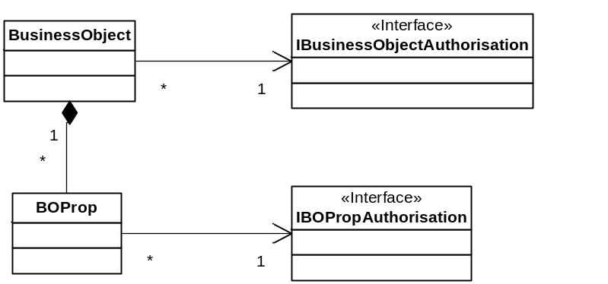
Chapter 3-5: The relationship between Business Object and the security interface.

The tests and setting up of tests for security is somewhat complicated so we will not go into all the details in this book. The test class TestSecurityCustomer has all the details required.
In summary if the security policy does not allow the business object to be read then the customer.IsReadable(out message); will return false and the message will give the reason that it is not readable.
The IsEditable, IsDeletable and IsCreatable work the same. IsCreatable is an instance method and not a static method since static methods cannot be overridden. These methods can be used by the User interface enable or disable controls. In addition these methods are used by the business object itself to prevent the Creating, Reading, Editing and Deleting of the Business Object. The tests in TestSecurityCustomer show this.
Below we have shown only the tests for Reading but there are similar tests for Editing, Deleting and Creating.

[Test]
public void Test_BusinessObjectAuthorisation_AllowRead_False()
{
//---------------Set up test pack-------------------
IBusinessObjectAuthorisation authorisationStub = new AuthorisationStub();
Customer customer = new Customer();
customer.SetAuthorisation(authorisationStub);

//---------------Assert Precondition----------------
Assert.IsFalse(authorisationStub.IsAuthorised(BusinessObjectActions.CanRead));

//---------------Execute Test ----------------------
string message;
bool isReadable = customer.IsReadable(out message);

//---------------Test Result -----------------------
Assert.IsFalse(isReadable);
StringAssert.Contains("The logged on user", message);
StringAssert.Contains("is not authorised to read ", message);
}

[Test]
public void Test_LoadExistingBO_Fail_AllowRead_False()
{
//---------------Set up test pack-------------------
IBusinessObjectAuthorisation authorisationStub = GetAuthorisationStub_CanCreate_True();
Customer customer = CreateNewCustomerValid();
customer.SetAuthorisation(authorisationStub);
customer.Save();

authorisationStub = GetAuthorisationStub_CanRead_False();
customer.SetAuthorisation(authorisationStub);
IPrimaryKey id = customer.ID;
BusinessObjectManager.Instance.ClearLoadedObjects();

//---------------Assert Precondition----------------
Assert.IsFalse(authorisationStub.IsAuthorised(BusinessObjectActions.CanRead));
Assert.IsFalse(customer.Status.IsNew);

//---------------Execute Test ----------------------
customer = BORegistry.DataAccessor.BusinessObjectLoader.GetBusinessObject<Customer>(id);
try
{
customer.GetPropertyValue("Prop1");
Assert.Fail("expected Err");
}
//---------------Test Result -----------------------
catch (BusObjReadException ex)
{
StringAssert.Contains("The logged on user", ex.Message);
StringAssert.Contains("is not authorised to read ", ex.Message);
}
}

From these tests you can see that all you have to do is set the correct authorisationPolicy when the Business Object is being constructed.
protected internal Customer(ClassDef def) : base(def)
{
SetAuthorisationRules(new CustomerAuthorisationRules());
}

Once this is done the framework will do everything else required. The example project ??? shows this in great detail. If no authorisation rules are set for a business object then it is assumed that everyone has create, read, update and delete permissions.
Note the IsEditable, IsReadable etc methods are overridable in the Business Object. It is important that these methods should be marked as Sealed methods in the Sub Classes since this will prevent malicious use of the Component by a developer who might try to inherit from the base class.

Applying Authorisation to a Business Object Properties
Business Object Properties follow a similar pattern to the Business object with the difference being that a BOProp can only have Read and Write (Edit) permissions set.
Permissions on a particular Business Object Property (BOProp) are much less frequent than permissions on a Business Object.

The BOProp Rules are again setup for a particular Business Object in its constructor redo should be set from a lazy initialisation method e.g.
protected internal Customer(ClassDef def) : base(def)
{
IBOPropAuthorisation propAuthorisationStub = new CustomerNameAuthorisationPolicy();
BOProp propCustomerName = (BOProp)this.Props["CustomerName"];
propCustomerName.SetAuthorisationRules(propAuthorisationStub);
}

The BOProp has methods IsEditable and IsReadable. These methods return true or false based not only on the security policy for the BOProp but also on the ReadWrite Rules set for the BOProp. These two methods can be used by the User Interface to enable/disable a control or in the case of IsReadable being false the user interface can blank out the control to show that it is not readable. Regardless of the user interfaced the Business Object and its business object properties will prevent the reading and writing of business objects properties where the rules prevent this. For detailed tests showing this functionality see the TestBOPropAuthorisation class in the Habanero.Test.BO.Security namespace of the Habanero.Test.BO Project that is downloaded with the application framework.

Applying Authorisation to a Business Object Method
The business object methods can also have security applied to them. In these cases the mechanism is similar but different since there is only one action that the user can do on a method and that is execute the method. The Interface used is IBOMethodAuthorisation An authorisation rules object of this type is created. The roles that can execute the method are added using AddAuthorisedRole probably during object construction and the method then calls IsAuthorised on the authorisation rules object prior to executing. If the use is not authorised then the appropriate error must be raised by the method.

Extending the Business Object
There are a number of points provided in the Business Object framework that are specifically intended for extending the framework. We will briefly mention each method, how it is intended to be used and where you can find tests that show their use.

AfterLoad
This method is virtual on the Business Object and by default implements no code. The application developer can override this method to carry out any custom code that is required after the object is loaded from the DataStore. This method will be called if the object is loaded for the first time or if the object is refreshed.

AfterSave
This method is virtual on the Business Object and by default implements no code. The application developer can override this method to carry out any custom code that is required after the object is saved to the DataStore. This method will be called every time the object is persisted.

UpdateObjectBeforePersisting
This method is virtual on the Business Object and by default implements code that add a transaction log object to the transaction committer in the case where a transaction log is defined for the Business object. The application developer can use this method to carry out any custom code that is required before the object is persisted to the DataStore. This method is called just before the object is persisted and allows the application developer to implement any custom code. A typical example where we use this is where there is a requirement to generate a custom number or sequential code for a business object. E.g. Each invoice must have a number which is unique. For these cases a particular implementation of the INumberGenerator class is usually used (Note the framework contains a few implementation of INumberGenerator). The INumberGenerator object is then added to the transaction Committer to ensure that the number generator and Business object are both either updated or rolled back. For more details on the TransactionCommitter see Section 4 – Data Access Layer.

Adding rules for a BOProp
The framework allows the Application developer to add custom BOProp Rules in addition to the standard rules defined in the ClassDefs.xml.
The PropRules are added to the BusinessObject in its constructor e.g.

protected internal Customer(ClassDef def)
: base(def)
{
BOProp propCustomerName = (BOProp)this.Props["CustomerName"];
PropDef propDef = (PropDef) propCustomerName.PropDef;
propDef.AddPropRule(new MyPropRule(this, propCustomerName));
}

AreCustomRulesValid
This method is virtual on the Business Object and by default returns true. This method is called prior to saving any Business Object. The application developer can override this method so as to implement any complex custom rules that cannot be dealt with through the IPropRule strategy. The disadvantage of placing custom rules in this method is that they are then not available as broken rules to the user interface making it difficult to show them using the ErrorProvider. Most rules could be implemented using either the IPropRule Strategy or the AreCustomRules Valid strategy the reason we allow both is that rules where the value of 1 property relies on the value of another property may not be best validated using PropRules. The best way to demonstrate this is via an example

Lets assume you have a Business Object that has a property for Date Of Birth and also for Identity Number. The identity number has 4 numerics that indicate the month and year of birth. There is a requirement that the date of birth is validated against the Identity number to ensure the month and year of birth are correct. A prop rule could be set on the DateOfBirth Validating against the Identity Number but this would imply that the identity number has already been captured causing a coupling between the Business Object being updated with an identity number and the Date of birth.IsEditable
By default the IsEditable Method checks the authorisation Rules set up for the Business Object. The Application developer can however override this and implement any other rules that may change whether the object is edited or not.
public virtual bool IsEditable(out string message)
{
message = "";
if (_authorisationRules == null) return true;
if (_authorisationRules.IsAuthorised(BusinessObjectActions.CanUpdate)) return true;
message = string.Format("The logged on user {0} is not authorised to update {1} Identified By {2}",
Thread.CurrentPrincipal.Identity.Name, this.ClassName, this.ID.GetObjectId());
return false;
}

IsDeletable
By default the IsDeletable Method checks the authorisation Rules set up for the Business Object. The Application developer can however override this and implement any other rules that may change whether the object is deletable or not.

Logging Edits
The Framework once again provides the Application developer with the hooks to implement a logging strategy if he/she requires. The required logging strategy is set up for the Business Object in its constructor using the protected void SetTransactionLog(ITransactionLog transactionLog) method. The framework also ships with objects that implement a particular logging strategy. For more details see the TestTransactionLogger class which shows the use of the TransactionLogTable.

Concurrency Control
The Framework once again provides the Application developer with the hooks to implement a any concurrency control strategy if he/she requires. Concurrency Control is a complicated topic and requires a fair amount of interaction with the database to implement. The subject is therefore fully discussed in the Section 4 – The Data Access layer. The Habanero Framework ships with a number of different implementations of various concurrency control strategies. The test classes TestConcurrencyControl_OptimisticLockingVersionNumberDB and TestConcurrencyControl_PessimisticLockingDB provide examples of setting up and using concurrency control in a business object.

The Business Object Collection
Business Objects are frequently loaded and used in collections.

Loading A business object collection
We will start with the simple loading of Business Objects. Business Object Collections are loaded in a very similar manner to Individual Business Object i.e. You can use either a string criteria or a criteria object that you have built up.
The tests for loading Business Object Collections are contained in the Test_LoadCustomerUsingStringCriteria Class. We are not going to repeat these but essentially the code for loading a business object is

const string loadCriteria = "CustomerCode Like Code%";
IBusinessObjectCollection loadedCustomers = GetBusinessObjectLoader().GetBusinessObjectCollection<Customer>(loadCriteria);

The Criteria Objects and Criteria Strings are much more powerful than shown so far and include all the normal operators required i.e. AND, OR, opening and closing brackets, <>, =, <>, >=, <=, >, <, IS NOT NULL, IS NULL, NOT LIKE, LIKE. All these operators work for loading collections of objects as well as for loading individual objects. Note however that if you try loading an individual object with a Criteria and more than one object is found in the database an error will be raised.
This test provides an example of how complex loadCriteria can be built up using strings. You can also build complex Criteria using Criteria objects.
public void Test_LoadCustomerUsingCriteriaString_Complex()
{
///This test shows that if a persisted object is loaded from the
/// dataStore using the BusinessObjectLoader.GetBusinessObject.
/// Then an object with the exact same status and data as
/// the persisted object is loaded.
//---------------Set up test pack-------------------
Customer customer = CreateSavedCustomer();
Customer customer2 = CreateSavedCustomer();
Customer customerNoMatch = CreateSavedCustomer("CustName", "NotMatch");
Customer customerNoMatch2 = CreateSavedCustomer("CustName", "Code");
Customer customerMatchOnCustomerName = CreateSavedCustomer("AlternateName", "Code");

//---------------Assert Precondition----------------
Assert.IsFalse(customer.Status.IsNew);

//---------------Execute Test ----------------------
const string loadCriteria = "(CustomerCode Like Code% AND CustomerName Like 'Valid Name%') OR CustomerName Like 'AlternateName%' ";
IBusinessObjectCollection loadedCustomers = GetBusinessObjectLoader().GetBusinessObjectCollection<Customer>(loadCriteria);

//---------------Test Result -----------------------

Assert.AreEqual(3, loadedCustomers.Count);
Assert.Contains(customer, loadedCustomers);
Assert.Contains(customer2, loadedCustomers);
Assert.Contains(customerMatchOnCustomerName, loadedCustomers);
Assert.IsFalse(loadedCustomers.Contains(customerNoMatch));
Assert.IsFalse(loadedCustomers.Contains(customerNoMatch2));
}

The business Object collection also provides helper methods that wrap the Business Object loader and provide the same functionality for loading a collection of business objects. See Test_LoadCustomer_UsingCollectionLoad.

Loading also provides a number of other capabilities including loading only a selected number of records and loading in a specific order (i.e. OrderBy Critieria). Once again the orderBy is always property names of the business objects and not database field names. See Test_LoadCustomer_UsingCollectionLoad_LoadWithLimit.

For a full set of tests showing all the functionality for Loading Business Object Collections is TestBusinessObjectLoader_GetBusinessObjectCollection in the Habanero.Test.BO project.

Future must be able to build custom criteria for any object that just need to put values e.g Criteria object called search by Surname, firstname and date of birth. All the UI developer needs to do then is use these criteria objects with the load. This will significantly improve the UIDevelopers experience especially with complex Criteria.
Load record 2-10 instead of only loadwithlimit see marks stuff

Other business object collection functions
There are many other functions that you can carry out for a business object collection these include. Adding an object to the collection (Add method), Removing (Remove method), Adding a Collection of Business Objects (Add method). Clear removes all objects from the collection, Refresh reloads the collection from the database. RemoveAt removes an object at a specified indes. Remove removes the specified Business object. Someone needs to put this in a table. Find there are a number of overloaded find methods.
Intersection and Union with other collections.
Sorting a loaded collection\
Insert

CreateBusinessObject

SaveAll do a separate set of tests for this showing the saving of all objects in the collection

Chapter 4: The Domain Model – Relationships

Relationships
Its all very well to be able to load business objects and to load collections of business objects but the power of the Domain model is really in correctly modelling the relationships between Business Objects.
To be able to discuss object relationships we need to define and explain a few terms.
Collaboration: Objects/classes are defined primarily by their responsibilities (What they are responsible for doing). To fulfill their responsibilities objects collaborate with each other. Collaboration occurs when one object asks another object to do something or asks another object for information this is done by sending messages. This implies that there is some sort of relationship between these objects.
Relationship: For an OO program to achieve anything the classes of the program need to collaborate with each other in various ways. These collaborations occur via relationships and method calls.

Persistent relationships: a semi-permanent relationship between two persistent objects that is persisted to an DataStore to be used by later (other) instances of the program.

Transient relationship: a relationship between two objects that is temporary in nature and is not saved.

Association: A relationship between two classes or objects.

Optionality: The concept of "do you need to have it?". E.g. Must an employee be associated with a department.

Cardinality: A relationship between two classes or objects. How many departments can an employee be associated with.

Multiplicity: UML combines the concept of optionality and cardinality.

Aggregation: Relationships between two classes or components defined as "is part of".

Composition: A strong form of aggregation in which the "whole" is completely responsible for its parts and each "part" object is only associated to one "whole" object. E.g Invoice and Invoice lines. The invoices lines only make sense in terms of the invoice. The invoice lines cannot be created, retrieved, deleted or persisted independently of the invoice. The invoice lines can never be moved to another invoice.
The differentiation between Aggregation and Composition has been dropped from UML 2.0 but is still frequently referred to in texts on Object Oriented system development.

Association Relationships In UML:
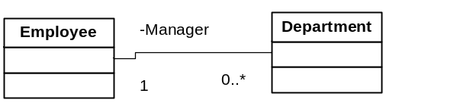
An association relationship is a persistent relationship between two classes.
Directionality. The open arrowheads indicate the directionality of the association. When there is one arrowhead the association is unidirectional: it can be traversed in one direction only (in the direction of the arrow). Where there are two or no arrowheads the relationship can be traversed in both directions.
Multiplicity. The multiplicity of the association is labeled on either end of the line, one multiplicity indicator for each direction. I.e. above an employee manages 0 or more departments. A department is managed by exactly 1 employee. Can have a car has 0..5 wheels for multiplicity. So more capability that an ERD which would merely have 0..*.
Label. The label, which is optional, is typically one or two words describing the association. Reading one class, the label, and then the other class should produce a sentence fragment that describes the relationship, e.g., Professor teaches Seminars. Avoid generic labels like "has" or "communicates with" as much as possible. E.g. Manages.
Role. The role—the context that an object takes within the association— may also be indicated at each end of the association. E.g. Manager.
Two classes can have more than one relationship between them. E.g. A person could lecture one course, Assist in another and be a student in another.
Relationships can be recursive E.g. An Employee manages Employees.
Association relationships are inherited i.e. a sub class of a class that has an associative relationship has the same relationship.
Implementing Associative relationships: Relationships are implemented in code. Industry norm is that the fields in the database used to implement relationships are not exposed by the business object. I.e. EmployeeID would not be exposed from the Department object above. The Employee would have a addManagedDepartment method, a removeManagedDepartment method and a getManagedDepartments method. In this bidirectional relationship case the Department would also have a getManager and may have a setManager method. Habanero implements slightly differently.

Aggregation Relationships In UML:
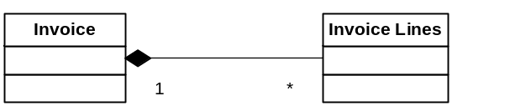
Aggregation is a specialised form of an Association relationship. The common test for aggregation is ‘Is Part of’.
E.g. an airplane is made up of a fuselage, wings, engines etc. A delivery shipment contains one or more packages. A project team consists of two or more employees. These represents "is part of" relationships
Composition is a strong form of aggregation in which the "whole" is completely responsible for its parts and each "part" object is only associated to the one whole object (see scott ambler). Even for composition there are various forms of strength of the relationship. E.g. An invoice is made up of invoice lines. If the invoice is destroyed its lines are destroyed, the lines cannot be associated with any other invoice (I.e. an invoice line cannot be moved from one invoice to another invoice), the lines cannot exist except as part of the invoice etc. Whereas a car is composed of its parts e.g. engine. While the engine is in the car the car is wholly responsible for it (i.e. the developer working with the car interface should not be calling Engine.increase speed). But the engine can be moved 2 another car and can exist by itself.
A delivery is composed of one or more packages is even weaker where the packages exist independently of the delivery and the delivery is merely a temporary convenient grouping of packages. The package can be moved from one planned delivery to another planned delivery.
Since Aggregation is a specialised form of an association it has all the properties of an assocation relationship multiplicity, roles etc.
Note: In UML2 you can no longer model Composition and aggregation differently both use the closed diamond now.
The following tips and techniques should help you to model composition/aggregation effectively:
- Apply the sentence rule. First should make sense to say "the part is part of the whole."
- The whole should manage the part. Secondly whether the whole manages the part. For example, an airplane should manage its engines.
- You should be interested in the part. An object may actually be a part in the real world, but if you are not interested in keeping track of it, then do not model it. For example, an airplane maintenance system would be interested in keeping track of engines because it needs to record maintenance information about each engine. On the other hand, an air-traffic control system is not interested in tracking engines, just airplanes.
Composition is inherited. Composition associations, like ordinary associations, are maintained by a combination of attributes and methods that can be inherited.

Dependency Relationships In UML:
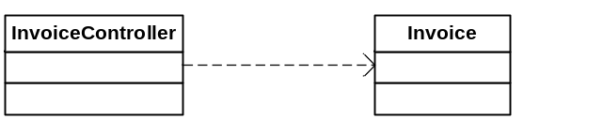
Dependency relationships are transitory i.e. the relationship is not saved.
All relationships between non persistable objects are by definition transitory. Transitory relationships may however occur between two persistable object. E.g. A course is passed a student object to determine whether the student has the required prerequisites to be enrolled on the course. (scott Ambler)

Inheritance Relationships In UML:
Two classes are often similar and may share similar methods or similar data (attributes). Inheritance is a relationship that allows you to reuse methods or attributes that are common. The inheritance relationship between two objects is one of the most powerfull relationships in object oriented programming but is also one of the most misused by less experienced developers. The Inheritance relationship is defined as an ‘Is a’ or ‘Is a type of’. A super Class in this case Contact is a class from which another class inherits a Sub Class in this case the Customer is a class that inherits from another class. In this case Customer Inherits from Contact. Contact may be an abstract or a concrete class.
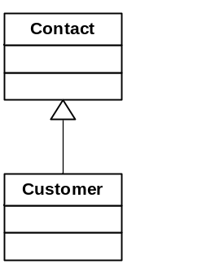

Relationships In Habanero:
From the above you can see that the correct identification of the relationship between two Business Objects is critical for a successful domain model.
Habanero provides a framework to implement any required relationship including Inheritance. The dependency relationship is obviously not modelled since it is not a persistent relationship.

Have cascading effects i.e. if a class is added to a relationship update automatically.
If class is removed update automatically
If a class is deleted update automatically

vs cascade update when required

1:M Relationships
OR
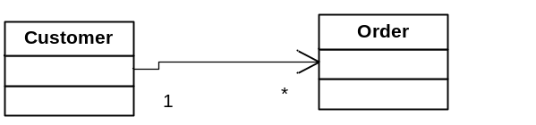

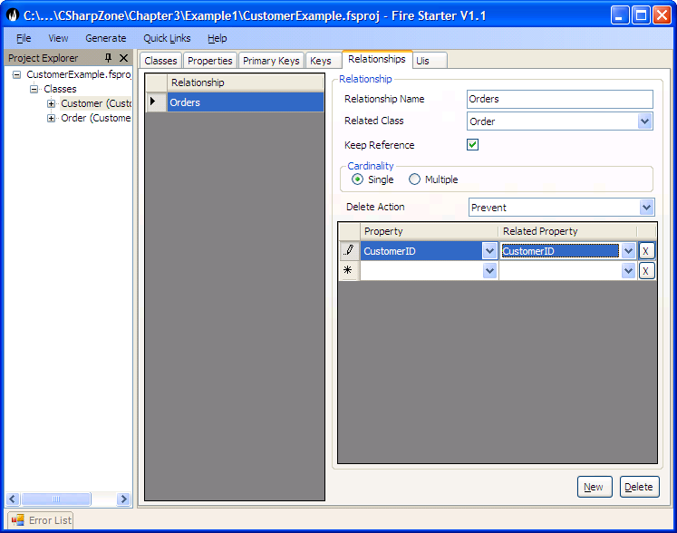

These relationships should implement the following.
ParentClassName | Name of the class that owns the relationship. E.g. Invoice/Customer
RelatedClassName | Name of the class that this relationship is to. E.g. InvoiceLines/Order
ParentClassRelationshipPropertyList | The list of Properties in the parent class that implement the relationship. i.e. what properties on Customer provide the values that relate to the Order. Ideally this will be the PrimaryKey of the Customer (CustomerID).
RelatedClassRelationshipPropertyList | The list of properties in the related class that implement the relationship. (Usually only one property the ‘Foreign key’ in the related class. E.g. The CustomerID in the Order Class.).
loadCriteria | This is used when the relationship has constraints. E.g. An Customer may have two relationships to Orders e.g. has a relationship current Orders (i.e. all orders that are not yet fulfilled) as well as a relationship of all the Orders that have ever been placed (including those that have been fulfilled).  This fulfils the role of a constraint modelled on the relationship in UML.
orderBy | By default what order do you expect to see the related objects loaded in e.g. Customer Orders must be loaded in delivery date the sort order for presenting on forms and in reports.
MinNumRelatedObjects | Can be 0 or more. In the case of a car having wheels the car can have a minimum of 3 wheels.
MaxNumRelatedObjects | Can be 2 or more. Once again in the case of a car maybe a max of 4 wheels (excluding issues like spare wheels)
Delete Action | What must the framework do when trying to delete the parent class if there are related objects. E.g. in the case of a customer the Customers orders make no sense without a related customer. In this case you would either set up to delete related (The framework will then delete all Customer orders if the customer is deleted) or prevent delete (The framework will prevent the deletion of the Customer if it has any related Orders but will allow the deletion if there are no related orders.)
CreateRelatedObjects | True if this relationship can create related objects. This would typically be a very strong relationship where the Parent object totally owns the child object e.g. An Invoice should create an invoice line. In most cases a customer should probably not create its Orders (This is a decision that is dependent on the domain).
DeleteRelatedObject | True if this relationship can delete related objects. In this case if a Customer Order is removed from the Collection of customer orders for a customer must it be deleted from the database.
RemoveRelatedObject | True if this relationship can remove related objects from its collection. I.e. if a Wheel is removed from its relationship to a car then the wheel should be dereferenced from the Car (since the wheel can exist as an object in the database without a reference to a Car).
AddObject | True if this relationship can add related objects to its collection (other than via CreateObjects). In the case of a wheel a wheel can be added to a Car and the wheel will then be related to the Car. This would be false in the case of an Invoice Line where the only way to associate an Invoice Line to an Invoice should be by the Invoice Creating the Invoice Line.
parentPersistsChildren | Does the parent of the relationship ‘own’ its children e.g. if an invoice is persisted then all edits to the invoice lines must also be persisted via the invoice. The save on the invoice line should thus throw an error.

If you Call CreateObject or Add Object then the objects relatedProperties will be updated with the parentsID and the object will be added to an AddedChildred Collection.?? Or should adding an existing object just add it to the main collection.
If you call DeleteObject is called then the object.delete is called and it is added to the DeletedChildren collection.
If you call RemoveObject then the object’s relatedProperties are updated to null. The object will be added to the relationships RemovedObjects collection.

When parent.Save is called then all the objects in the added, deleted and removed collections will be persisted. Note in the case of objects being removed or added where the parentPersistsChildren is not set true we should consider only updating the related properties and leaving any other dirty properties.

Questions: Should the relationship register for the updated/deleted etc event of all of its children I think so.
Should the parent register for the updated/deleted events from its relationships?

Cancel Edits on Parent must this cancel all the relationships.

Think of having warning for save and cancel as well as errors.
E.g. BO has .CanSave and CanDelete that returns UserWarning and msg or UserError and Msg
The Save will however only throw a UserError

How deal with a child that deletes independently of the parent? How get msg back to parent.

M:1 Relationships
OR
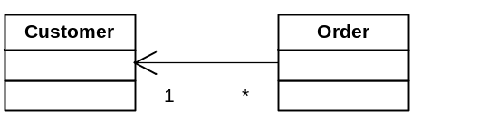
The M:1 relationship is the reverse of a 1:M relationship. This relationship is required when you need to access the relationship from the many side e.g. A Customer Order needs to be able to access the customer that it belongs to or an Invoice line needs to access the invoice. This relationship is very simple e.g. The Order will have a method GetCustomer which will return the customer related to the order. Whether the relationship is compulsory or not is determined by the rules set on the property i.e. if the CustomerID property on the Order object is set as Compulsory then the relationship is compulsory else the relationship is set as optional.

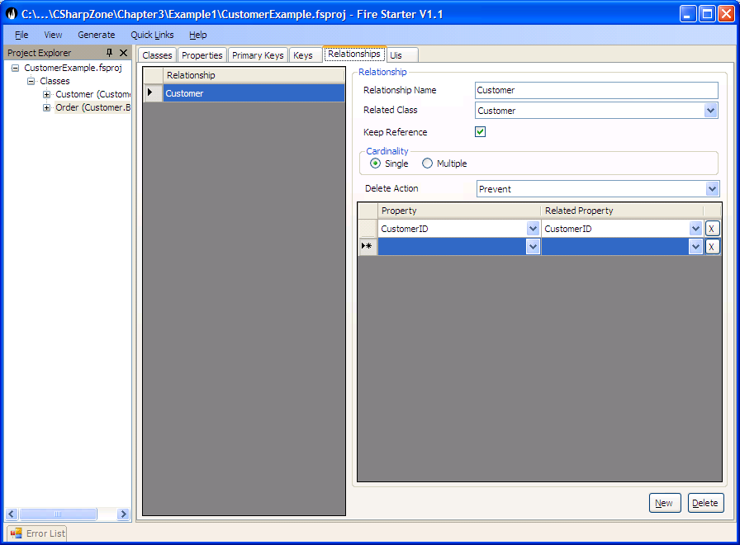

The M:1 relationship should implement the following.
ParentClassName | Name of the class that owns the relationship. E.g. InvoiceLine/Order
RelatedClassName | Name of the class that this relationship is to. E.g. Invoice/Customer
RelationshipName | In some cases the relationship name will differ from the related class name e.g. if an Employee of a company is the manager of a department then this relationship between the department and the person has a relationship name of manager.
ParentClassRelationshipPropertyList | The list of Properties in the parent class that implement the relationship. i.e. what properties on Customer provide the values that relate to the Order. Ideally this will be the PrimaryKey of the Customer (CustomerID).
RelatedClassRelationshipPropertyList | The list of properties in the related class that implement the relationship. (Usually only one property the ‘Foreign key’ in the related class. E.g. The CustomerID in the Order Class.).
Delete Action | This should always be Do Nothing

1:1 Relationships
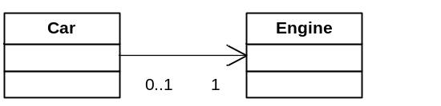

The 1:1 relationships is modelled in firestarter in the same way that the M:1 is modelled. The only real difference is that if the relationship is navigated in both directions then the reverse relationship is also a 1:1. In a 1:1 relationship it is not as obvious which object should have the foreign key reference. In these cases we recommend that if there is some sort of an owning relationship then the foreign key is placed on the child e.g. in this case the Engine. Firestarter and Habanero effectively work out both directions of the relationship regardless.

M:M Relationships
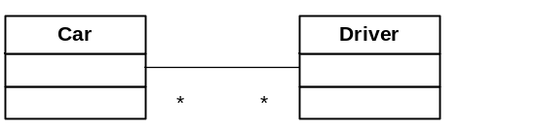
The Many to many (M:M) relationship is a lot less common than the relationships discussed so far but is still fairly common. Many people confuse a true M:M with two 1:M relationships this is often the result of how these are modeled in the database but in Domain Modeling there is no need to implement an intermediate class. At this point it is important to understand a true M:M. This occurs when two objects such as a driver can be permitted to drive many cars and a car can be driven by many drivers. There is no extra information stored on the M:M relationship. This is different from what is sometimes mistaken as a M:M but is actually two 1:M’s i.e. when the relationship stores extra information e.g. Employee : Department, this appears to be a M:M but in fact the relationship has additional information e.g. the date that the employee joined the department.
If you find yourself using lots of M:M relationships then you should review your domain model as this might indicate a problem.
At the moment you cannot model a M:M directly into Firestarter.
Car Class
Get Driver
Could have code that checks if the getCarsCollection IsLoaded so as to avoid loading Cars unneccessarily.
AddDriver(Driver addedDriver)
{
CheckAddedDriverNotNull
CheckAddedDriver not already associated with the Car.
addedDriver.getCars.Add(this);
this.Drivers.Add(addedDriver);
}

Inheritance Relationships In Habanero:
TODO: fdsafsafdasf
rivate Vector instructors;
public void addInstructor(Professor professor)
{
// If the professor does not exist in the collection
add it
// The if statement avoids an infinite loop managing
the association
if (! getInstructors().contains(professor)) {
getInstructors().add(professor);
// Update the other end of the association
association
professor.addSeminar(this);
}
}
public void removeInstructor(Professor professor)
{
if (getInstructors().contains(professor)) {
getInstructors().remove(professor);
// Update the other end of the association
professor.removeSeminar(this);
}
} This is an excellent technique we need to consider this would require relationships to cross reference related relationships.

Composition, Aggregation, Association

Chapter 5: Creating a Domain Model
Any developer who has spent any time developing enterprise applications will agree that the hardest part of programming is to understand the Customers Business i.e. The domain of the application. It therefore stands to reason that you should build your software to match the domain of the business as closely as possible hence the domain model. Resulting in a single shared language between the programmer, the program and the businessPossibly out of place here. The domaim model is independent of the UI.

Although this is not a book on Software development methodologies while training developers on Domain Modelling we are often asked how you go about building a domain model, using firestarter and developing a system using Habanero. We have found that there is no one way of doing things and that each project has a different ideal approach depending on the environment e.g. The knowledge of the customer on what he/she wants, the experience of the team in the domain. the experience of the team with the technologies, the physical, business and emotional relationship with the customer, the experience that the team has working together, the inherint risk of the project (i.e. an aircraft control system is higher risk than a library admin system).
These are difficult to quantify but we have found that the higher the risk the shorter the iterations are between feedback.

If you are replacing an existing system and making virtually no changes to the functionality of the system, you understand the technologies well and have reasonable experience in the domain then you can probably create a fairly complete domain model up front and implement this domain model. Your model would typically contain at least a class diagram and if you are using a relational database then an ERD. You can implement the database design and reverse engineer the classes from the database design using Firestarters powerfull reverse engineering capabilities. The Businesss Objects, relationships, properties and Object to relational mappings will all be modelled for you where the firestarter wizards will assist you with these mappings.
As you develop the system you may find minor changes in which case you can modify the model in Firestarter and regenerate the code. During maintenance when additional requirments are found the model can be updated in Firestarter and the code regenerated. Firestarter also generates basic (CRUD) user interfaces but the user of Firestarter for this will be discussed in section

If you are developing a system for a business application that you do not know well or a new type of application where the customer does not even really know what they want then you should create a detailed model of only the smallest piece possible (System under development). You should iterate between Analysing Modelling, Developing and testing with the customer Stakeholders (user/customer/business analyst) as quickly as possible. In addition you should only detail the domain model when needed. Following the agile principle of delaying detailed design until needed.
Firestarter has been designed to be used in the most agile manner possible and in fact we have found that using Firestarter to manage the refactoring of the Domain model has a massive impact on the agility of a project and on the management of change in the domain model.
The best way to demonstrate Firestarter being used in this manner to to work through an example.

DO A USE CASE
Implement test 1
Model a business object required
Generate
Expand test 1
Add to model
Generate

……
Note: At this point you need not have developed any database since all the tests are executing against a memory database for agile development this creates an incredible benefit since the software can be developed, unit tested prototyped and tested for usability and usefullness without having to manage a relational database. This significantly increases the agility of the process since the model can be refactored in Firestarter with ease.

If you have a class model in place a good start is to do a one-to-one mapping of your classes to data tables, an approach that works well in "greenfield" environments where you have the luxury of designing your database schema from scratch. Because this rarely happens in practice you need to be prepared to be constrained by one or more legacy database schemas. which you will then need to map your classes to. In these situations it is unlikely that you will need to do much data modeling; you will simply need to learn to live with the existing data sources, but you will need to be able to read and understand existing models. In some cases you may need to perform legacy data analysis (Chapter 14) and model the existing schema before you can start working with it. From Scott Ambler

Refer to Doman-Driven Design – Tackling complexity in the heart of software by Eric Evans.
A rich domain model on a large project provides an ubiquitous language for the entire team to communicate in the language of the problem domain. A good domain model with the appropriate automated tests provides the basis for software that can continue to grow and improve with the business instead of suffering from ‘software entropy’ and becoming legacy software. A domain model is a model of reality and will thus only represent the aspects of reality that are relevant to the particular problem being solved by the project. The domain of a software program is the subject area of interest and activities that the software is used. To be able to create a useful software program it is essential that the team acquires the required domain knowledge. A domain model can be expressed as diagrams, text or code, the domain model does not have to match ‘reality’ but is instead a model of the characteristics of the domain that are relevant for the particular set of problems and/or activities being solved by the software program.

The utility of a domain model – from evans pg 4
A domain model and the software design and implementation shape each other and map to each other. The domain model is represented throughout the actual software and will be useful during software maintenance.
The domain model provides a common language that is used by all team members. This provides the developers with a common language that they can talk about their programs with as well as with which to communicate with domain experts.
The model provides distilled knowledge and as such distinguishes the areas of most interest. The user of a rich model through all the versions of the system allows the various versions of the system to feedback to the domain model allowing the model to grow and develop.
Evans Emphasises repeatedly in his book that the Domain model is not a set of diagrams a requirement/design document but is instead a language which becomes ubiquitous and is present in the diagrams the actual code, the tests, the coffee machine chats and the conversations held between developers different modules, analysts, domain experts and users. With Model-Driven design the model is owned by all members of the team. The old divide of Analysts, Designers and programmers who communicate primarily via UML and documentation does not work. The modeller must be involved to some extent in the design and the programmer is always involved in the model.

What gets modelled in this? The business objects of interest to the business, the relationships to them, the rules for updating editing and deleting business objects as well as security relating to using the business objects.

Examples
- An Invoice has one or more Invoice Lines.
- If an Invoice is deleted then all its Invoice lines must be deleted.
- An Invoice that has been revenue recognised can never be deleted.
- An Invoice is created for one and only one customer order. The Customer Order must be approved for an invoice to be created.
- Once Invoice line is created for each customer order item that the Invoice is associated with.
- An Invoice line will be associated with one or more Case. Where a Case is a single package of a specific Product delivered to a Customer.
- An Invoice Line Value is compulsory and must be greater than zero.
- An Invoice line must always be associated with an individual Invoice. Each Invoice line has a line number. An invoice cannot have two invoice lines with the same invoice line number.
- Only users of the ‘Account Manager’ profile can add or remove cases from an invoice. Cases can never be added or removed if the Invoice has been revenue recognised.
- Only users of the ‘Customer Service’ Profile can create an invoice.
- Only users of the ‘Accounting’ Profile can revenue recognise an invoice.
There are many more rules for this system but these have been selected as examples of rules that are modelled in the domain layer. In addition the system has been separated into separate sub systems as per this diagram. For the purposes of this example the Customer and all related rules and data have been left out of the model.
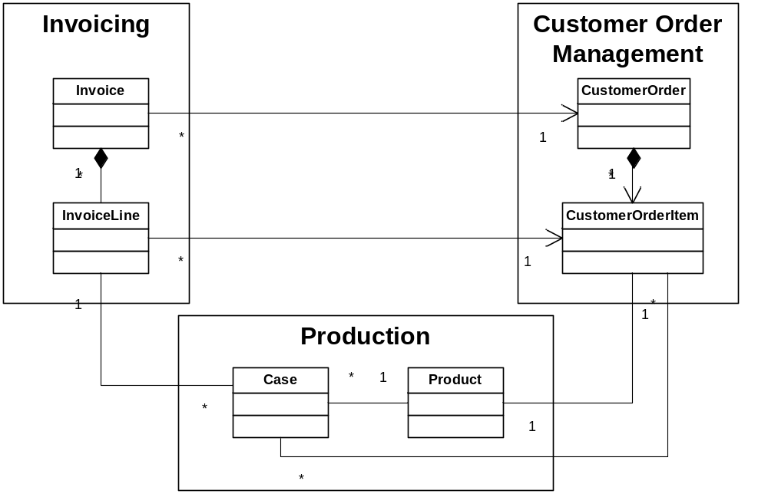Capturing the Domain Model using Firestarter
Firestarter (a Domain modeller – program generator and Data Mapper) and Habanero (an application framework) work together to assist the application developer to focus on and implement a domain model like this without having to focus on the complexities of Object-Relational mapping, Security implementation, Business rule implementation etc. This frees the application developer up to concentrate on the modelling and developing the core business problems. This not only results in dramatic improvements in productivity but also in the quality of the final application.
The first thing we do is model the two Business Objects modelled as part of the Invoicing sub system in the above analysis.
The XML file containing the definition discussed here is contained in downloads – Chapter3\Invoicing.fsproj.
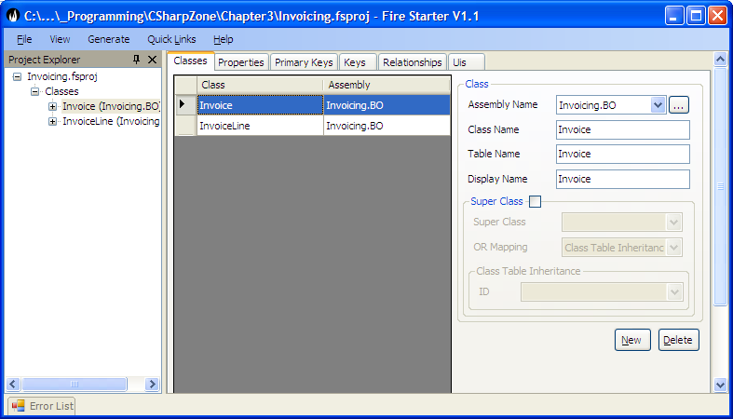
Then we model the various properties that each Business Object has in our case the Invoice Line has a line number – the sequence number of the line printed on the invoice, a line description – a textual description of the invoice line and a value the amount that the customer is being charged.
Each of these properties of a business object can have rules set for it. We will demonstrate this by adding the property Invoice Line Value to Invoice Line.
From this we can see that the InvoiceLineValue is
- Type Decimal.
- Read Write Rule of Write New i.e. it must be set to a valid value before the object can be persisted for the first time else the object will be in an invalid state. The InvoiceLineValue can never be updated after the object has been persisted to the database. The other options for Read Write Rule are
- Default value. If the property has any default value that is set when a new Business object is created.
- Description: This is the description of a business object property which is used for tool tip text on user interface, generated XML documentation for the property etc.
- Compulsory: If true the business object will not be in a valid state and will not be persistable to a datasource until this property is set to a non null value.
- Validation. This allows the Application developer to capture common domain property rules. The rules captured differ for the different property types but are typically Min Value, Max Value for most data types and for strings, Min length, Max Length and a Regular Expression Pattern Match.
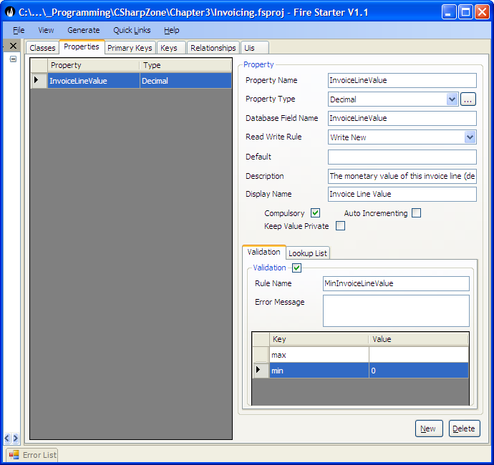

Each object will have a unique object identity (ObjectID). In Habanero and Firestarter the nature of this ID is very flexible and the various options are discussed in Object Relational Mapping (Chapter). For our purposes the Object will be modelled with a GUID identifier which is an classical ObjectID. The property modelled for it is by convention called the InvoiceLineID.
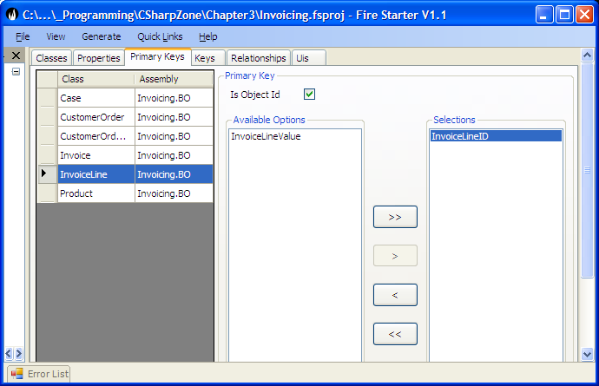

For each object you can also identify alternate keys. This is a single or a group of properties that are unique for the Business Object and act as a constraint to ensure that two Business Objects cannot be persisted with the same values for the alternate key. E.g. An invoice cannot have two invoice lines with the same invoice line number.
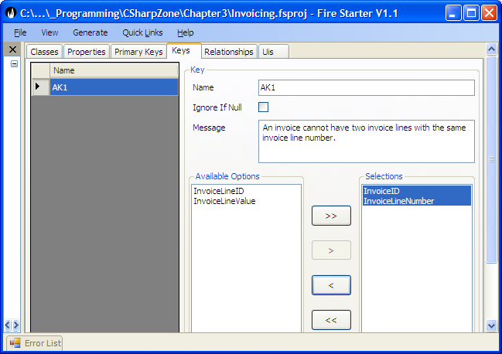

The last important value to be modelled in Firestarter is the relationships between two business objects. We will show the relationship between Invoice and Invoice line namely.
- An Invoice has one or more Invoice Lines. (Multiple)
- If an Invoice is deleted then all its Invoice lines must be deleted. (Delete Related)
To model these we create a relationship between Invoice and Invoice Line. This relationship represents the rules above. The Order By and Property and Related property will be explained in detail in the chapter on Object Relational Mapping (Chapter xx)
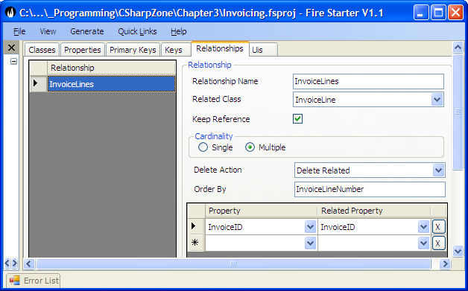

Chapter 6: Implementing this domain model using the Habanero Framework.

Generating the Business Objects
Once the Model is captured into fire starter we can generate Code (Ctrl G). This will generate a number of folders for the various application layers, a solution file, project files and some C Sharp files (.cs)
For the Business Object layer this will generate an XML file (ClassDef.xml) representing the Class Definitions captured in Firestarter and the Code to use interpret and use this definition file. The Application developer does not need to concern himself

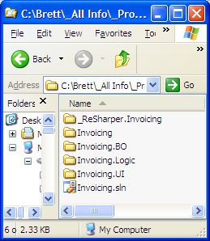

At the moment we are interested in the BO layer which a project file a ClassDef.xml file and 4 .cs files.
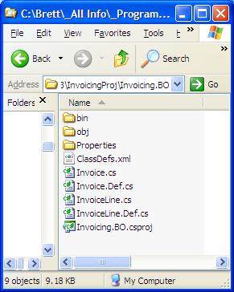

The two .Def.cs files contain the automatically generated code using partial classes and these should not be edited since they will be regenerated any time that the project is regenerated.

A brief look at these two files will show the code generated based on the Model captured in FireStarter.
Invoice.Def.cs has the relationship InvoiceLines which returns a strongly typed collection of invoice lines.
public virtual BusinessObjectCollection<InvoiceLine> InvoiceLines
{
get
{
return Relationships.GetRelatedCollection<InvoiceLine>("InvoiceLines");
}
}

And the InvoiceLines.Def.cs has the properties defined in FireStarter
public virtual Guid? InvoiceLineID
{
get
{
return ((Guid?)(base.GetPropertyValue("InvoiceLineID")));
}
}
public virtual String InvoiceLineNumber
{
get
{
return ((String)(base.GetPropertyValue("InvoiceLineNumber")));
}
set
{
base.SetPropertyValue("InvoiceLineNumber", value);
}
}
public virtual Decimal? InvoiceLineValue
{
get
{
return ((Decimal?)(base.GetPropertyValue("InvoiceLineValue")));
}
set
{
base.SetPropertyValue("InvoiceLineValue", value);
}
}

As well as the single relationship Invoice which returns the Invoice related to the Invoice Line.
public virtual Invoice Invoice
{
get
{
return Relationships.GetRelatedObject<Invoice>("Invoice");
}
set
{
Relationships.SetRelatedObject("Invoice", value);
}
}

From the simplicity of this code it is obvious that that the Validity and Read Write rules captured in Firestarter are not represented here. This is because these are all represented using the ClassDef.xml File. This file along with the relevant classes implements the MetaData mapping pattern (See Fowler – 306).

The Application Developer should not be required to view or edit the Definition file but it is important to understand conceptually how the file works to implement the Business rules of the domain model.

<classes>

<class name="Invoice" assembly="Invoicing.BO">
<property name="InvoiceID" type="Guid" readWriteRule="WriteNew" compulsory="true" />
<primaryKey>
<prop name="InvoiceID" />
</primaryKey>
<relationship name="InvoiceLines" type="multiple" relatedClass="InvoiceLine" relatedAssembly="Invoicing.BO" deleteAction="DeleteRelated" orderBy="InvoiceLineNumber">
<relatedProperty property="InvoiceID" relatedProperty="InvoiceID" />
</relationship>
</class>

<class name="InvoiceLine" assembly="Invoicing.BO">
<property name="InvoiceLineValue" type="Decimal" readWriteRule="WriteNew" compulsory="true" description="The monetary value of this invoice line (determined by the product price multiplied the mass of all the cases invoiced)">
<rule name="MinInvoiceLineValue">
<add key="min" value="0" />
</rule>
</property>
<property name="InvoiceLineID" type="Guid" readWriteRule="WriteNew" compulsory="true" />
<property name="InvoiceID" type="Guid" readWriteRule="WriteNew" compulsory="true" />
<property name="InvoiceLineNumber" compulsory="true" />
<key name="AK1" message="An invoice cannot have two invoice lines with the same invoice line number.">
<prop name="InvoiceID" />
<prop name="InvoiceLineNumber" />
</key>
<primaryKey>
<prop name="InvoiceLineID" />
</primaryKey>
<relationship name="Invoice" type="single" relatedClass="Invoice" relatedAssembly="Invoicing.BO" deleteAction="DoNothing">
<relatedProperty property="InvoiceID" relatedProperty="InvoiceID" />
</relationship>
</class>

</classes>

Using the Business Objects
If you look at the Invoice and the InvoiceLine you will notice that both Classes inherit from Business Object. From this you can conclude that much of the interesting behaviour associated with the Invoice and Invoice lines is inherited from BusinessObject.
From the ClassDef.xml you can see that all the Properties, Relationships and Rules defined in FireStarter are generated to this ClassDef.xml File.
To implement this Habanero makes extensive use of the Layer SuperType Pattern (Fowler -xxx )

Setting a Business Object Property
When a business object property is set by the user of the business object e.g. using code such as invLine.InvoiceLineValue = 12.00m; We will demonstrate that the functionality and use of the business object via tests that show the changes that occur to a business object when the objects state has changed.

[Test]
public void TestUpdateInvoiceLineProperty()
{
//---------------Set up test pack-------------------
InvoiceLine invLine = new InvoiceLine();

//---------------Assert Precondition----------------
Assert.IsTrue(invLine.State.IsNew);
Assert.IsFalse(invLine.State.IsValid());
Assert.IsFalse(invLine.State.IsDeleted);
Assert.IsFalse(invLine.State.IsDirty);
Assert.IsFalse(invLine.State.IsEditing);

Assert.IsTrue(invLine.State.IsValidMessage.Contains("'Invoice Line Value' is a compulsory field and has no value"));
string inValidReason;
Assert.IsFalse(invLine.IsValid(out inValidReason));
Assert.IsTrue(inValidReason.Contains("'Invoice Line Value' is a compulsory field and has no value"));

Assert.IsNull(invLine.InvoiceLineValue);
IBOProp prop = invLine.Props["InvoiceLineValue"];
Assert.IsFalse(prop.IsDirty);
Assert.IsTrue(prop.IsObjectNew);
Assert.IsFalse(prop.IsValid);

//---------------Execute Test ----------------------
invLine.InvoiceLineValue = 12.00m;

//---------------Test Result -----------------------
Assert.IsTrue(invLine.State.IsNew);
Assert.IsFalse(invLine.State.IsValid());
Assert.IsFalse(invLine.State.IsDeleted);
Assert.IsTrue(invLine.State.IsDirty);
Assert.IsTrue(invLine.State.IsEditing);
Assert.IsFalse(invLine.State.IsValidMessage.Contains("'Invoice Line Value' is a compulsory field and has no value"));
Assert.AreEqual(12m, invLine.InvoiceLineValue);

Assert.IsTrue(prop.IsDirty);
Assert.IsTrue(prop.IsObjectNew);
Assert.IsTrue(prop.IsValid);
}

If all you intend to do is utilise the Habanero Framework and Firestarter then this is all you need to know about the Framework and you can stop here. You can return to the remainder of this chapter at a later stage.

List the main namespaces and classes of interest.
Generic types and the fact not polymorphic how overcome this with interface i.e. IBusinessObjectCollection.

Tracking objects status valid dirty, new, markedForDeletion, etc.
IsNew : When object is creates marked as new.
Load from Database: IsNew = False.
It is not assumed that all data in the database is valid the reason for this is that business rules can be modified over time and the recently loaded business object may now no longer pass the validation rules.

Property level dirty tracking such that only the properties that are dirty are updated to the datastore. This reduces the probability of concurrency control failures.

Deleting objects from database deferred or immediate. The deferred approach is used here i.e. the object is marked as deleted when the UI developer calls save the object is physically deleted from the database.

Custom rules historical data

Validation – Any custom or standard rules are verified and marked as broken when the property value is changed however an exception is only thrown if the UI developer tries to save an object that is in an invalid state.
The framework creates the BusinssObjectInvalidStateException which is thrown. The UI developer can therefore easily catch this exception when required.

Authentication and Authorisation: Authentication is the process of logging a user on. Authorisation is the process of verifying that a user may use certain features e.g. Edit An object View a particular property or object..

Non Duplication of code so security is implemented for business object and its properties.
This can then be used by the UI Developer to disable certain buttons on the UI as required (typical in windows development) or to raise appropriate error if the user is not authorized (typical in ASP web development). Of course the UI developer could implement more sophisticated security if required. This feature is implemented using the strategy pattern so that the Application developer can implement any security strategy required. The application developer could therefore implement a strategy using any custom security or using the security provided in Chillisoft security. The implementation as a strategy means that if no security strategy is implemented then there is no performance cost in having security as part of the framework.

GetHashCode, ToString, Equals should be implemented by every business object.
Object ID maybe should be virtual check
Lhotka: businessObjectBase is generic page 141 why?

System.Security.Principal.IPricipal – this is the standard security interface in .Net.
This exposes the IsInRole method.

Tracking state IsDirty if the object or any of its children are dirty.
IsValid if the object and all of its children are valid. The object is valid if all of its properties are valid.

Details of lookup lists. Simple, Business Object??

public class BindingList<T> : System.Collections.ObjectModel.Collection<T>
Member of System.ComponentModel

Summary:
Provides a generic collection that supports data binding.

Very practical view of the main issues facing developers developing systems in business environment. We do not delve into the theory unless it is necessary to understand the issues. There are many books covering the theoretical aspects of most of these issues we have however found a dirth of books that help a real life developer implement solutions for these issues in real life.

Section 4 – Data Access Layer:
The storage and retrieval of data from a datastore is arguably the most critical part of an Enterprise Application. This section provides guidelines for implementing data storage and retrieval with minimum effort and the total elimination of repetitive SQL or mapping code. In addition to showing how to do this we will also discuss how this is done so as to not only achieve portability between vendors of various relational databases who implement slightly different dialects of SQL but also portability between different datastored e.g. XML and Memory dumps. Habanero tackles this difficult enterprise application problem by implementing an Object Relational Mapping strategy (ORM). This strategy is steadily gaining acceptance as the preferred data access strategy for developing enterprise applications.

Although we recommend that you at least skim through this chapter. If you just want to get started using Habanero then you can skip this entire chapter since firestarter automates the generation of all database mappings. You can then use this chapter as a reference when you come across one of the more complex mappings namely Many to Many and Inheritance hierachies.Although this book is about developing Enterprise applications using Habanero to fully utilise the power of Object Oriented Design (Domain drive design) while storing your data in a relational database requires at least a basic understanding of the various options and design patterns that are used in designing the various solutions. In this section we are therefore going to show these problems and how they can be solved in Habanero.

Chapter ix: Object relational mapping
All the examples developed so far in Section 2 where developed using an In Memory Datastore. This shows the incredible power and flexibility of Habanero in being able to plug in any datastore e.g. an XML datastore.
The most commonenterprise data store is still however the relational database. As mentioned previously there is inherently a significant impedance mismatch due to the different objectives of objects and tables. Objects represent and model behavior whereas tables model data. At the same time objects also have state the state of the object may last over the lifetime of a single object. In these cases this state needs to be persisted. In the case of a relational database normalized to the third normal (or Boyc Codd Normal) form the objects state will be stored in one or more tables and each of the objects persistant properties will be stored as a field on one or more of these tables. For the purpose of retrieval each object must be uniquely identifiable ideally globally but at least within its class.

What is a relational database.
A relational database …Normalisation of data…The most common enterprise datastore and is thus almost always used in an enterprise application. Tabular representation of data in tables with rows and columns

The impedence mismatch
modern object oriented software uses sophisticated domain models that are not represented by rows and columns in a table. The rich domain model allows the application developer to develop an application using sophisticated object oriented concepts and patterns in the language of the domain. The habanero ORM ensures that the developers interaction with fjdla;fjdsa.
SQL
Habanero totally isolates the developer from having to write SQL for data access. We will therefore not go into any detail on SQL even though you may use it to create custom views or stored procedures.

The domain model is inheritantly richer than the Relational model.

Non entity types e.g. Address that is stored in same table as user but is a specific type (money is another example) See evans for more discussion.

Unique identity of an object map to the Primary key of a table.

The fit between object technology and RDB technology is not perfect. In the early 1990s, the difference between the two approaches was labeled the object/relational impedance mismatch, also referred to as the O/R impedance mismatch or simply the impedance mismatch, terms still in common use today. Why does a technological impedance mismatch exist? The object-oriented paradigm is based on proven software engineering principles. The relational paradigm, however, is based on proven mathematical principles. Because the underlying paradigms are different, the two technologies do not work together seamlessly. The impedance mismatch becomes apparent when you look at the preferred approach to access: With the object paradigm you traverse objects via their relationships, whereas with the relational paradigm you join rows of tables. This fundamental difference results in a nonideal combination of the two technologies, although when have you ever used two different things together without a few hitches? Scott Ambler

There is also a cultural impedance mismatch between developers in the object community and data professionals in the data community. Object developers have been taking an evolutionary (iterative and incremental) approach to development for years and are now quickly moving towards agile development methods such as extreme programming (Beck 2000), Scrum (Beedle and Schwaber 2001), feature-driven development (FDD) (Palmer and Felsing 2002), and agile modeling (Ambler 2002). Unfortunately many within the data community look upon evolutionary development as a questionable approach, and agile approaches (Ambler 2003b) are just now being considered. Object developers typically take an object-oriented approach to modeling using unified modeling language (UML) diagrams, whereas data professionals focus on data-oriented models such as logical data models (LDMs) and physical data models (PDMs). Furthermore, many object developers are not skilled at data modeling and data professionals are not skilled at object modeling. When it gets right down to it the real issue is that data professionals view the world as data to be manipulated, whereas object developers view it as objects to be combined to perform behavior.
Due to these two impedance mismatches, one technological and one cultural, it can be very difficult to succeed at object persistence. Unfortunately we have little choice in the matter: these are the two technologies that we typically have to work with, and so we need techniques to overcome the inherent challenges. The goal of this chapter is to describe how you can effectively develop the data aspects of your business software.

Object persistence: Object Relational mapping, Concurrency control, Transacitonal support.
The term "mapping" refers to how objects and their relationships are stored in a relational database
Some attributes of an object are objects in their own right; in the class model Address.state is actually a State object. As you saw in Chapter 13 this really reflects an association between the two classes; association mapping is described in Section 14.2.3. For now trust me that the two models in Fig. 14.1 map to one another.
Remember that not all attributes are persistent; some are used for temporary calculations. For example, a Student object may have an averageMark attribute that is calculated by the object but is not saved into the database. Similarly, as you see in Fig. 14.1 not all table columns map back to your object schema—there is no corresponding attribute for the State.Capital column. The important thing to understand is that at some point each attribute of a class will be mapped to zero or more columns.
Mapping is only this clean when you have control over both your object and data schemas. In situations where you cannot easily change the database schema, which is typical when you are working with one or more legacy databases, you will find that the mappings are much more complex. In these situations mappings between classes and tables become many-to-many—the attributes of a class will map to the columns of several tables, and any given table will have several classes mapping to it. You may even have several attributes mapping into the same column (and worse yet vice versa). When you are working with a legacy database you may need to do significant legacy analysis (Section 14.7) if adequate documentation is not in place. You will also find that you need to write code to encapsulate these complex mappings, perhaps in the form of data access objects (DAOs) discussed in Section 14.3.

Mapping Inheritance Structures
Relational databases do not natively support inheritance, forcing you to map the inheritance structures within your object schema to your data schema.
There are three primary solutions for mapping inheritance into a relational database:
- Map the entire class hierarchy to a single table.
- Map each concrete class to its own table.
- Map each class to its own table.
Having said that, I have found that the single table per hierarchy approach is often your best option.
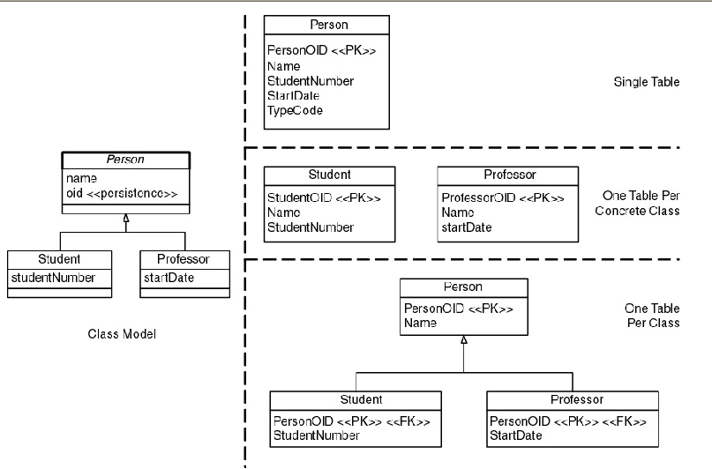
Table 14.1: Comparing the Three Techniques
Technique | Advantages | Disadvantages
Single table | - Simple approach. | - Coupling within the class hierarchy is increased because all classes are directly coupled to the same table. A change in one class can affect the table, which can then affect the other classes in the hierarchy and their related mappings.
 | - Easy to add new classes: you just need to add new columns for the additional data. | - Potential space wasted in the database because many rows will have empty columns.
 | - Supports object polymorphism by simply changing the type of the row. | - Indicating the type becomes complex when significant overlap between types exists (e.g., someone is both a professor and a student).
 | - Data access is fast because the data are in one table. | - Table can grow quickly for large hierarchies.
 | - Ad hoc reporting (Section 14.5.6) is very easy because all of the data are found in one table.
One table per concrete class | - Good performance to access a single object's data. | - Modifications to classes require you to modify its table and the table of any of its subclasses. For example if you were to add birthDate to the Person class you would need to add columns to the Person, Student, and Professor tables.
 | - Ad hoc reporting simple because all of the data you need about a single class are stored in only one table. | - Whenever an object changes its role, e.g., perhaps the university hires one of its students, you need to copy the data into the appropriate table.
 |  | - It is difficult to support multiple roles and still maintain data integrity. For example, where would you store the name of someone who is both a professor and a student?
One table per class | - Simple mapping because it is one-to-one. | - There are many tables in the database, one for every class (plus tables to maintain relationships).
 | - Easily supports object polymorphism because you merely have records in the appropriate tables for each type. | - Potentially takes longer to read and write data because you need to access multiple tables.
 | - Very easy to modify superclasses and add new subclasses as you merely need to modify/add one table. | - Ad hoc reporting is difficult, unless you add views to simulate the desired tables.
 | - Data size grows in direct proportion to growth in the number of objects.

Doing a good job of object relational mapping requires a good understanding of object modelling and relational database modelling. Object relational mapping is thus difficult it is further complicated by the fact that not all object oriented programming environments support the same features. Programming environments implement different data access and data management capabilities. Relational databases are deficient in implementing core relational theory. In addition to this all relational database vendors support different features and capabilities.
For the purposes of this book we will thus deal with OR mapping between the .Net environment and the major database vendors Oracle, SQL server, MSSQL and MSAccess Jet database engine.
Relational theory is primarily with the access and management of data (knowledge). Object Modelling is primarily concerned with behaviour. It is here that we find what is commonly referred to as the Object relational dissonance or mismatch.

Object Modelling
Basic principles
Identity (OID):- Objects have a unique and immutable identity which distinguishes them from all other objects in the given system for all time. The objects identity is independent of the state of the object. OID’s are never reused.

State:- The current value of the object. The state of the object should be encapsulated and should only be visible by examining its behaviour.

Behaviour:- Objects provide an abstraction that other objects (‘Clients’) can deal with. The behaviour of an object is the collection of operations (‘methods’) that the object provides (its interface). All interactions with an object is via its interface.

Encapsulation:- abstraction of behaviour that prevents the implementation details being seen from outside of the object.

Persistence:- An object can persist beyond the lifetime of the application session. During this time an object must be stored in a file or Database.

It is way beyond the scope of this book to discuss methodologies and processes for capturing requirements, Object Design techniques etc. There are many excellent books on these subjects including (The Object Primer – Third Edition by Scott Ambler. Enterprise applications). The philosophy of Design has also changed in the last few years with Agile methodologies being applied more and more (An Excellent book that summarizes the various methodologies and how to select one is ‘Rapid Application development’ Steve m) For the purposes of this book We assume that you have a number of classes that you wish to model in application and which you wish to persist in the database. See chapter xxx which will go through a brief walkthrough of how firestarter an application modeler and generator can be used to support both agile and traditional software development methodologies.

Relational Database modelling:- normalisation.

ORM

Mapping Relationships
For the purposes of our discussion the term relationship shall apply to either associations or composition associations as there is no significant difference between the two from a mapping point of view. Relationships in object schemas are implemented by a combination of references to objects and operations, whereas in RDBs they are maintained through the use of foreign keys. A foreign key is a data attribute(s) that appears in one table that may be part of or is coincidental with the key of another table.
The way that you map a relationship depends on its multiplicity:
- One-to-one relationships. To map a one-to-one relationship you have two strategies. If each class corresponds to a table, which we see in Fig.14.4 with the Course and CourseVideo classes, then a foreign key needs to be implemented in one of the two tables. In this case the CourseV- ideo.CourseNumber column acts as the foreign key to the Course table. From a data point of view it does not really matter which table the foreign key goes in, although if the relationship is unidirectional association then it makes sense to have the foreign key in the table corresponding to the class that maintains the relationship. For example, if there is a unidirectional association from Person to Address then add the foreign key into the Person table. The second mapping strategy is to simply store the data for both classes in a single table, the approach we took to map the relationship between the Course and CourseOverview classes.
Figure 14.4: Mapping associations.
- One-to-many relationships. One-to-many relationships, such as offering of in Fig. 14.4, are implemented in classes via a collection such as a Hashset on the many side of the relationship and by an object reference on the one side of the relationship, in this case Course.seminars and Seminar.course, respectively. Within the database the relationship is implemented via a foreign key on the many side of the relationship, in this case Seminar.CourseNumber.
- Many-to-many relationships. A many-to-many relationship between two classes is mapped to an associative table within a database. This table comprises the primary keys of the two business tables. In Fig. 14.4 the instructs relationship between the Professor and Seminar classes is mapped to the Instructs table within the database. By adding an associative table like this we say that we have resolved the many-to-many relationship by converting it into two one-to-many associations.
A general rule of thumb with relationship mapping is that you should keep the multiplicities the same; i.e., a one-to-one object relationship maps to a one-to-one data relationship, a one-to-many maps to a one-to-many, and a many-to-many maps to a many-to-many. The fact is that this does not have to be the case; you can implement a one-to-one object relationship with to a one-to-many or even a many-to-many data relationship. This is because a one-to-one data relationship is a subset of a one-to-many data relationship and a one-to-many relationship is a subset of a many-to-many relationship. However, implementing a one-to-one or a one-to-many as a many-to-many is an example of overbuilding your software so I discourage it.
A recursive relationship, also called self or reflexive relationships, is one where the same entity is involved with both ends of the relationship. For example, the prerequisites association in Fig. 14.4 is recursive, representing the concept that a course may be a prerequisite to other courses. There is nothing special about recursive relationships; you map them the exact same way that you would a nonrecursive relationship. For example, because the prerequisites association is many-to-many I simply map it to the Prerequisites associative table.

From the above discussion
Overcoming impedence
(Start with the simple case ignoring inheritance we will tackle inheritance just now and ignoring relationships)
E.g. To map a person class to the database
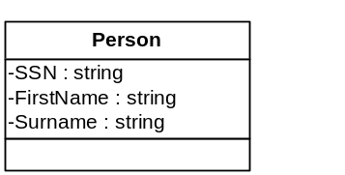
- For each persistable class create a table.
- For each persistable field (attribute, property) of the class create a column (attribute) for this table.
- Add an additional attribute to the table for the object ID.
- Set the object ID as the primary key.
- Set any other natural keys as alternate keys.
Person Table
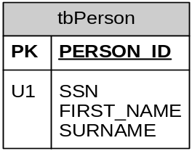

Mapping relationships
Mapping Class relationships to a relational database is now relatively easy.
- Mapping aggregation and composition 1:M
Composition and aggregation is where one object is made up of or contains other objects. The common examples are a file consists of the papers in the file. A team is made up of the players in the team. A house is composed of walls, floors, windows. (See Object modelling above)
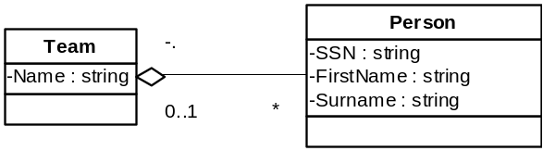
If a Team is an aggregation of the players in the team then the
  - The Team class is mapped to the database as for the person class.
  - The Team ID is mapped as a foreign Key in the person table.
  - The aggregation relationship is mapped as a 1:M Database relationship.
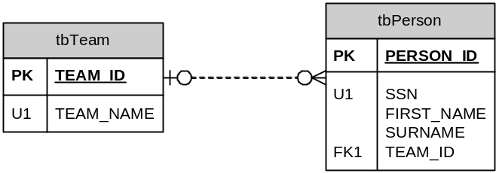
- Mapping composition and aggregation 1:1
This is a somewhat artificial example but lets say we treat the person an aggregation of their parts i.e. the Person has one Heart.
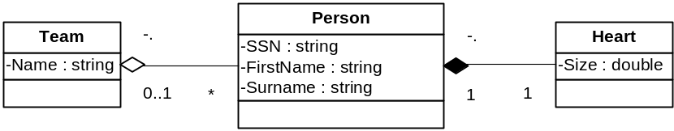
  - This mapping is very similar to the 1:M above.
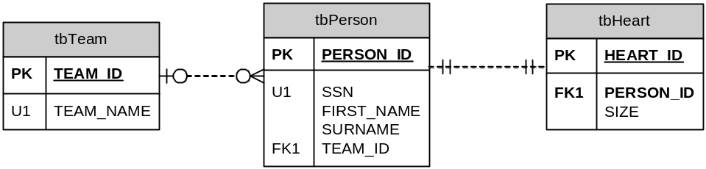
- Map 1:M relationships
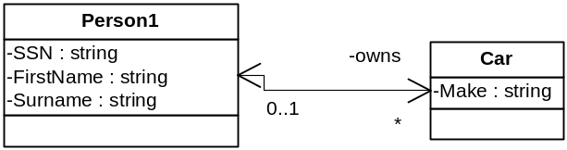
  - The person can own one or more cars.
  - The car can be owned by one and only one person.
  - This relationship is shown as navigable in both directions. Whether the relationship is navigable in one direction or both directions does not affect the mapping to a relational database.
  - We map this the same way we did the 1:M aggregation above by creating a Person_ID foreign Key in tbCar.
Note there is nothing in the database to show the difference between the Team – Person relationship and the Person – Car relationship. You can give the database relationship a name but this adds little value.
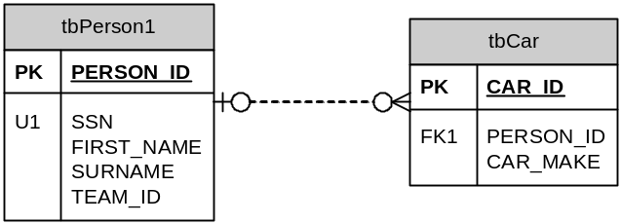
- Map 1:1 relationships
We will map the relationship that a Team has a home ground.
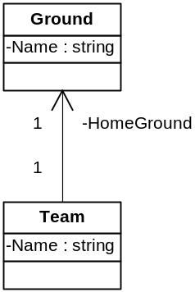
  - This relationship is shown to be navigable in only one direction.
There are a few choices in doing this mapping.
    - Option 1. We create the Team_ID as a foreign Key in tbGround.
    - Option 2. We create the Ground_ID as a foreign Key in tbTeam.
    - Either of these solutions will be equally acceptable from an Object relational mapping perspective.
    - Our standard has become to place the foreign key in on the navigable relationship if there is only one.
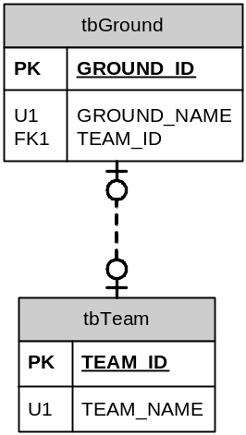
- Map M:M relationships.
For this example we have a relationship between the player position (Full Back) and Player. In this case we have a Position which can have zero or more players but we also have Players who can play one or more Positions. This type of relationship is very common, however it is very important to differentiate between this relationship and two 1:M relationships the difference comes is whether the relationship contains any data e.g. in the example below if the Player has a first position and alternate positions e.g. the player is a centre but can stand in as a full back then this relationship is not a many to many but is instead two 1:M relationships one between the Player and the PlayerPosition and the Other between Position and PlayerPosition. In the case of a true M:M the Position will have a collection of players and the player a collection of positions.
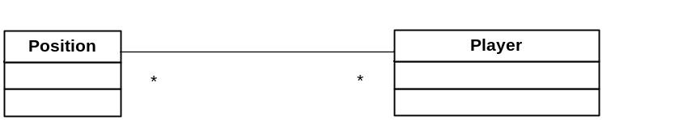

  - When mapping a many to many to an ERD or a database model the rules are fairly simple an associative entity is created between the Position and the Person. Thus creating two 1:M database relationships instead of the many to many.
  - The associative entity will hold the primary key of both tables as a foreign key and the composite of the two primary keys will be a unique constraint on the associative entity.
  - The only additional decision that needs to be made for the Database mapping is whether the primary key for the TeamPerson should be a composite key consisting of Team_id and person_ID or whether Team_ID, Person_ID should be set up an alternate key and a Team_Person_Id is created.
    - The rules for this are fairly simple if the M:M class relationship is implemented as an associative class then you must create a Team_Person_Id since an object id is necessary.
    - If the M:M class relationship is implemented via two collections then there is no need to create a new ID.

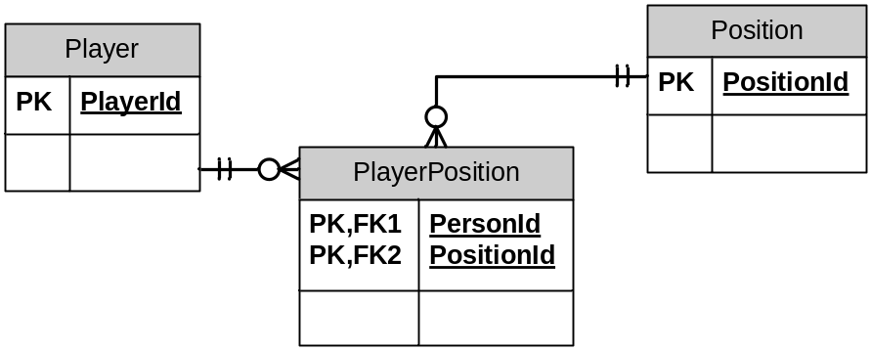
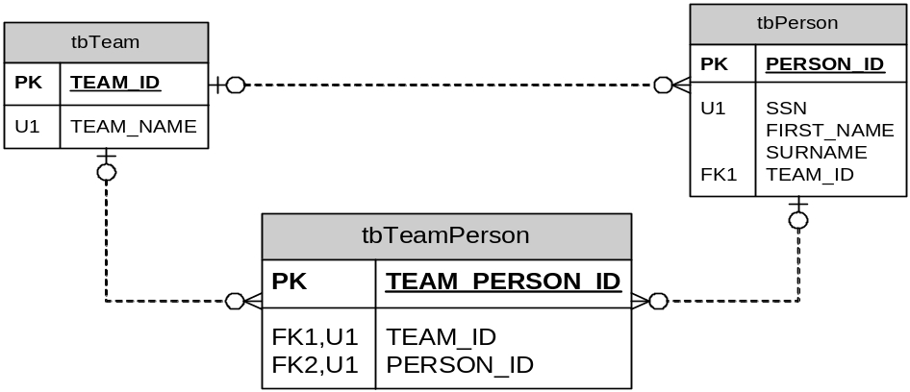
For more info see Association Table Mapping pattern – Fowler 248. The Link Table (Player Position should have no corresponding in memory object as a result it does not require its own object ID although I have seen a number of database designs which still do this. The primary Key for PlayerPosition is a compound key consisting of PersonID, PositionId.
- Lookups
Lookups are not really relationships between two objects but will be discussed here. In reality a lookup is a rule for limiting the validation for a particular property to limit to a particular set of data e.g. The values in the lookup set of data are very seldom changed or updated e.g. a person may have a Title e.g. Mr, Mrs, Doctor, Honour. The available options are often provided to the user via a Combo box or equivalent. The business object then merely needs to validate the input value against the list of available values. Typically lookup lists are not modeled in the object model but will be modeled as a separate table with a 1:M relationship in the Relational Database Model.
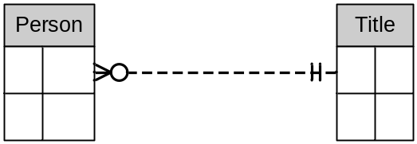
- Self referencing relationships.
This relationship is simple an Object has a relationship to itself e.g. A Person Managed Other People. The normal rules apply to this relationship i.e. it can be a 1:1, 1:M or M:M. In the database is represented by having the primary key as a foreign Key.
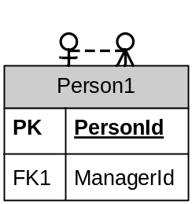
- Inheritance relationships
One of the powerful features of object oriented programming is the ability to have classes inherit behaviour from other objects. The classical example often used is A Circle Inherits from Shape and a Filled circle inherits from a Circle.
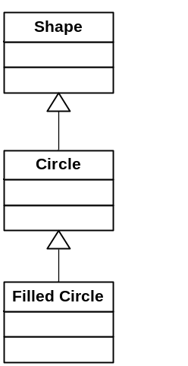
This is easy enough to implement in C# the complexities however build when mapping to a database. Typically Business Objects that inherit from each other will not only inherit behaviour but will also be required to inherit properties. Each inherited class can also have additional properties. In these cases there are a number of commonly used Inheritance hierarchy - Database mappings. The Inheritance mappings supported by Habanero are ‘single table inheritance’, ‘Class table Inheritance’ and ‘Concrete table Inheritance’. A summary of the advantages and disadvantages of each mapping strategy will be given the discussion of each strategy.
- Single Table Inheritance – Fowler (278) – ‘Represents an inheritance hierarchy of classes as a single table that has all the columns for all the fields of the various Domain classes’. This has the simplest implementation mapping of inheritance -Database mapping that can be implemented. Every field required by any class in the inheritance hierarchy is mapped to a related field in only one table. Any column that is not required by a particular class is left empty and is neither updated or loaded when that class is loaded. I.e. Firstname will not be loaded when a Contact of type ContactOrganisation is loaded. When loading or saving an object to/from the database no joins are required. Each row of the Contact table will have one additional field (The Discriminator field) that will identify the name of the class that this row represents e.g. ‘ContactPerson’ or ‘ContactOrganisation’. When loading from the database this field is used to determine which sub class to load. When inserting the record the Discriminator field is updated.
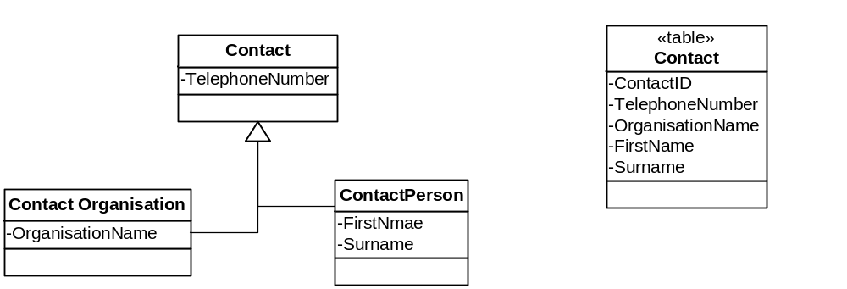

- Class Table Inheritance – Fowler (285) – ‘Represents an inheritance hierarchy of classes with one table for each class’. This is conceptually a simple mapping since every class is mapped to one table and the database relationships between the tables map to the inheritance relationships. The fields unique to each sub class are represented in only the relevant table. There are two options option 1: Each table has as its primary key the ID from the super class. In our example below each table will have its primary key as the ContactID. This is the preferred option where the developer has control over the database design since the inheritance relationship is more obvious when viewing the database design alone. Option 2: each sub class table has its own primary key and in addition to this has a foreign key that references the Super class table. The complexity of this mapping strategy relates to the loading since loading all the contacts requires complex logic to load the correct sub class (i.e. ContactOrganisation or ContactPerson).
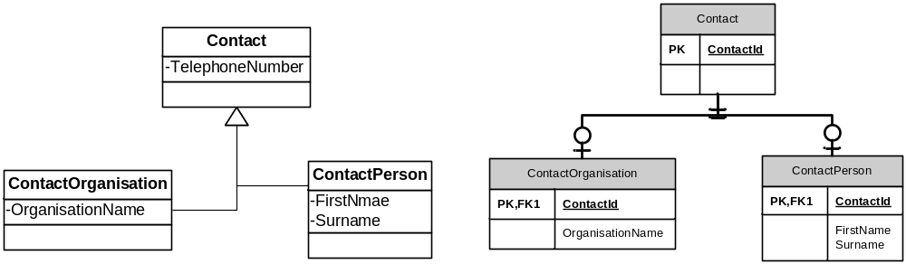
- Concrete Table Inheritance – Fowler (293) – ‘Represents an inheritance hierarchy of classes with only one table for each concrete class in the heirachy’. This is conceptually a simple mapping since every concrete class is mapped to only one table. All the fields for every concrete class are represented in each table that is mapped. The complexity of this mapping strategy relates to the loading since loading all the contacts requires complex logic to load the correct sub class (i.e. ContactOrganisation or ContactPerson). 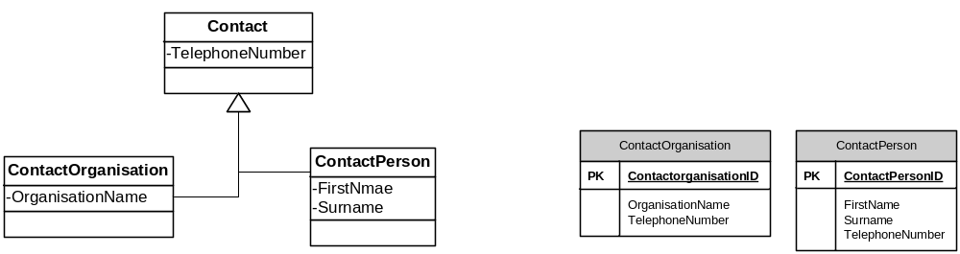
- When to use each inheritance mapping strategy.
Our suggestion is that you always start with single table inheritance since these results in the least complexity in the database and is easiest to adapt and modify as your system evolves. If you have any sub classes that have a lot of fields and data that are different from the other classes then use Class table inheritance for this class only. Only use Concrete table inheritance when the sub classes only share common behaviour without sharing many common fields or persistant relationships to other business objects.

For a detailed discussion of when to use each inheritance mapping strategy see Fowler – Patterns of Enterprise application architecture (pg 278 – 301).

Concurrency control
When several users/applications try to read and write to a single object simultaneously then you create a contention for an object. This can result in several disastrous consequences such as losing changes made by one user (commonly known as lost updates).

The types of concurrency control issues that can occur are.
Note: In all these cases we refer to user but this could just as well be a program etc.
- Lost Updates
  - User 1 and User 2 read an object from the database.
  - User 1 makes edits to the data and persists these edits to the database.
  - User 2 makes edits to the data and persists these edits to the database thus overriding User 1’s edits.
- Stale Data for an object.
  - User 1 reads an object’s from the database e.g. The details of an individual soccer player.
  - User 2 edits the object that User 1 is viewing. E.g. the player is updated as injured.
  - User 1 now has stale data any decisions made reports printed etc are made with ‘out of date’ information.
- Stale set of objects
  - User 1 reads one or more objects from the database e.g. A list of all players in a soccer team.
  - User 2 edits one or more of the objects that User 1 is using or modifies the set of objects that user 1 is using. E.g. A new player is added to the soccer team or an existing player is updated as injured.
  - User 1 now has stale data any decisions made reports printed etc are made with ‘out of date’ information.
- Lost delete (this is in fact a specialised version of lost updates)
  - User 1 and User 2 read an object from the database.
  - User 1 deletes the object and persists the delete to the database.
  - User 2 edits the object and persists the object to the database. One of two things happen depending on the way that the programmer has written the code.
    - User 2’s updates are lost since the object has been deleted.
    - User 2’s updates are persisted to the database and the User 1’s delete is lost.
- Duplicate data
  - User 1 captures data for a new object. E.g. For a new soccer player.
  - User 2 captures data for the same new object. E.g. for the same new soccer player.
  - A duplicate soccer player is created in the database with two different object ids.

Strategies to Concurrency control issues.
- Pessimistic Check out – Check in (Single write access, multiple read access)
  - Many programs can read the data for an object.
  - When a client object wants to edit the data it must first obtain a checkout.
  - While this client object has the data checked out no other client object can edit the data, many other objects can however still read the data.
This strategy for concurrency control eliminates lost updates and lost deletes but does not prevent or help duplicate data or stale data.
- Pessimistic Check out – Check in (Single read and single write access).
  - Only one client object can read data at a time.
  - The client object will check out the object when it begins reading and will check in the object when it is completed.
This strategy for concurrency control eliminates lost updates and lost deletes and stale data for an individual object but does not assist with stale data for a set of objects or duplicate data.
This strategy is seldom generally usable for normal business objects since it would result in an excessively restrictive environment but is useful in certain instances such as generating a unique invoice number that must be guaranteed to be unique and sequential.
- Optimistic locking
  - All client objects have read and write access to all the data.
  - The client can update the data to the database if the data has not been changed since it read the data.
This strategy is useful where the severity of a conflict is low and/or where the probability of a conflict is low. This is generally the easiest strategy to implement and is the least restrictive.
This strategy resolves the lost updates and may or may not solve the lost deletes depending on how it is implemented.
- Data Polling
  - Client objects or sets of client objects have the ability to poll the server (database) to ensure that its data is still current and to refresh it if required.
  - This type of solution can be employed where an object or a set of objects poll the database at specific points. E.g. when an object is currently displayed in a form or a collection of objects is displayed in a grid then it will regularly poll the database for any changes or at certain specified points the object will be required to refresh the data if it has gone stale.
This strategy primarily addresses the stale data issues and can be used in conjunction with pessimistic read multiple write once locking or with optimistic locking.
This can have significant performance overheads and must be used with circumspection.
- Last save wins
This is not really a concurrency control mechanism but is the mechanism most novice programmer’s use (often unintentionally). This mechanism basically ignores concurrency control issues and the last user to save to the database wins and overwrites all previous users’ data.
- Messaging
  - When a client object or a set of client objects is created from the server it can register for messages from the server.
  - Any time that this object’s data is changed by another client object it is notified via the message.
  - The client object can then react accordingly.
This strategy is similar to the data polling solution.
In a high transactional volume system this can add significant performance overhead.
The architectural requirements of this type of system are more limiting than the other strategies in that an application server of some type is required so that client objects can register for messages and be sent messages.

As we can see the duplicate data is the most difficult concurrency problem to solve.
The data polling and messaging do however go some way towards preventing this type of error since the data that the user is viewing is fresher. This is particularly true when messaging and polling is used for a set of object e.g. a set (collection) of all players playing for a team is loaded. The set (collection) then polls the database for any changes to its data if an object has been deleted, added or removed from the set the set (collection can be updated or the appropriate warnings can be given).

Hence the reasons for concurrency control mechanisms.
Pessimistic concurrency control: Pessimistic locking only one application/user can have access to a single object at any one time. Pessimistic write locking many users/applications can obtain read permissions to an object but only one can have write permissions at any one time.
Optimistic concurrency control: ……

Transaction Committer:- Implements the Unit of Work Pattern (Fowler 184 ‘Maintains a list of objects affected by a business transaction and co-ordinates the writing out of changes and the detection and resolution of concurrency problems’).

Custom loading e.g. for Blobs to implement lazy load.

Need flexibility to extend domain-DB mappers for loading and updating. This can be maintained in the ClassDef if need some bizarre loading for one or more object can write custom loader this will be used instead of standard.

Relational database implementation.

Implementation:-
There will be many cases where the developer is working in environments where he/she will not be able to determine the database design to organizational standards or due to working with old databases (That cannot be changed because of all the reports running off of that etc). The ideal is that each object is globally uniquely identified via a Guid (In SQL Server a Unique Identifier). The reasons are numerous but are briefly other techniques (e.g. autonumbers) do not assign the id until the data is inserted into the database. This means that the identity of the object is unknown until it is persisted for the first time the complexity of managing and persisting related objects is therefore significantly increased. Techniques using composite natural keys provide an even worse set of problems typically the key values can be modified resulting in significant overhead in matching the updated object to the original record in the database as well as the overhead of managing relationships a huge increase in the potential and severity of concurrency control issues. However having said this because Habanero has evolved from real life practices over many years it has been developed to be able to handle all these scenarios.

I think it is generally better to err on the side of simplicity whenever possible. Writing a bunch of mindless stored procedures to perform every operation you think you may need is definitely not simple. I’m certainly not ruling out the use of stored procedures, but to start with procs? That seesm like a fairly extreme case of premature optimization to me. Jeff Atwood, codinghorror.com
Stored Procedures vs Dynamically generated SQL: In the Habanero architecture we prefer to use generated SQL to retrieve and update transactions into the database the reasons for this are many but are summarized below. Having however said this the Habanero Framework is sufficiently well designed and responsibility segregated that stored procedures can easily be used. It is however slightly more work for the application developer since the powerfull capabilities where the Habanero Framework dynamically creates optimised SQL is lost. With stored procedures the true ease of use of the Habanero Object relational mapping capabilities will not be realised. All the other advantages and benefits of Habanero are still however realised

Karl Seguin (codebetter.com)
Three major benefits of an O/R mapper
      - You end up writing less code – This results in more maintainable systems and quicker deliver.
      - You gain true abstraction from the underlying data source – You are querying the OR mapper for your data not a database and the mapping between the table schema and domain objects is abstracted.
      - Your code becomes simpler and less repetitive (DRY).
      - DRY. The mapping is done in one place the updating, inserting, loading and searching all use the same mapping so you eliminate duplicate mappings.

Dynamic SQL is generated on the fly by a generic piece of code which gets various data as input and generates a parametrized query from it. Dynamically generated paramaterised sql will be cached on the server. In our case the SQL is dynamically produced from the Habanero Business Objects.
SQL dynamically generated from the Business object definition is the least brittle interface to the database possible.

Issue | Dynamic SQL | Stored Procedures
Maintainability | To add a new field onto a table and support it as a property in the object the database must be updated and the business object definition must be updated. That’s it two places. (As close to DRY as we can get)  Dynamically generated SQL provides for better testability. I.e. The system can run automated self test by testing that each and every property required by each and every class is represented appropriately in the database thus ensuring that the system is more robust than using stored procedures or non dynamically generated SQL. | Stored Procedures are in effect an API changes to an API must always be treated with extreme respect.  Adding a new field to a database that uses stored procedures requires one of two options  1) the existing stored procedure(s) are modified. This can cause a nightmare of ensuring that all versions of the software and all users of the stored procedure are updated at the same time.  2) A new stored procedure is created with the new field. This results in an explosion of stored procedures and difficult maintenance since you are never certain which are being used by whom.  Remember that there will usually be at least 3 stored procedures involved in this change, the select, update and insert.  In addition to the updating the stored procedure the business object have to have the new property and the business object reading updating and writing all need the new property added.
Sorting and searching. | Dynamic SQL can easily handle any combination of sorting and querying with minimal effort. Search by a different field no problem. Once again conforming to DRY. | The combinations of searching and sorting have to be known up from so that the stored procedure can have it built in. This add significant overhead to making relatively simple changes.
Sql Injection | Dynamically generated parameterized SQL cannot be subjected to SQL injection attacks. | Stored Procedures Cannot be subjected to SQL injection attacks.
Security | There are many options for implementing excellent security using Dynamic SQL. We have implemented all of these an even more sever security mechanisms when appropriate. Dynamic SQL can be used to provide even superior security to Stored procedures where the user has no permission to anything in the database see option 4.  1) Setting up role based security in the database where each user is assigned a role and that role is given permissions to certain tables.  2) Even each application and not each user is given permissions to the database. The password for the application is stored in the application using the appropriate encryption. No user ever has any permissions to do anything in the database.  3) Use views. Views can be set up in such a way that the users only ever have permissions to the views and never to any underlying tables. The users with inappropriate permissions can therefore never view sensitive information.  4) Based on the windows or custom security roles that the user has for the application the user is assigned to database roles for the particular connection being used. This provides the ultimate security but with performance and complexity overheads. | You set up the stored procedures and apply appropriate execution rights. The user need not have any permissions to any underlying tables.
Portability | Dynamic SQL can be built in such a way that it is fully portable to any relational database. The Habanero architecture allows the developer to move from MySQL to MS SQL, Oracle, FireBird, MSAccess etc with only a configuration change. Any currently unsupported Database can be supported with less than 4 hours work and once supported all systems developed using the Habanero framework will work on the new database. | Stored Procedures are difficult to port from on database to another and require rewriting and retesting to move.
Performance | For years we assumed that stored procedures gave performance advantages over Dynamic SQL. On one project we were however requested to test the performance loss as part of the decision making in choosing between stored procedures and Dynamic SQL. We know that ever since SQL 2000 the execution plan for Parameterised Dynamic SQL is cached in exactly the same manner as are stored procedures.  Well yes even knowing this we and everyone else was surprised with the dynamically generated parameterized SQL performed at least as well as stored procedures and in many cases significantly better.
Performance | Using Dynamic SQL provides the capability to read data from ADO using or ordinal position instead of named variables. This has an order of magnitude performance advantage over using named fields. (see Section 4)
Performance | Execution Plan Cached | Execution Plan Cached
Performance | Updating data can easily be optimized to only update fields that are actually dirty (this is done with Habanero). As an extreme example if a Boolean field is changed then only that field is updated to the database and not the BLOB field.  In a similar manner loading and refreshing objects can be easily optimized to only load and refresh relevant data from the database. | The ability to have a stored procedure for every combination of fields that could be updated for each table would be prohibitive. In specialized cases e.g. the blob example two stored procedures could be created. This however makes the maintenance problems even worse than before.
Supports Incremental development and delivery | Dynamic SQL and Business objects provide the optimal condition for incremental development and incremental delivery preferred by agile development. The arguments are the same or similar to the maintainability arguments above.  Agile development methodologies are therefore significantly easier if you at least start with dynamic sql. Later you can change to stored procedures if there is an advantage. | Stored procedures are usable for incremental development and delivery but present more challenges.

For all the above reasons we have selected to use Dynamic parameterized SQL as our primary mechanism for interfacing to Relational databases.

The Habanero architecture is designed such that stored procedures are fully supported it just requires the additional effort on behalf of the application developer to develop stored procedures.

Section 5 – UI Layer
UI – BO there are many views of how a user interface should be built to handle errors. One view is that the user should be prevented from entering any invalid data into the user interface. I.e. masked edits, preventing letters in a numeric field etc. The other extreme is that the user interface should allow invalid data and the validation logic (in the business object) must validate this data and present the appropriate error to the user explaining the error. Most applications exist somewhere between these two extremes but regardless of which extreme the onus is on the business object developer to protect the business object from misuse (i.e. no invalid data must be allowed into the business object).

SmartDate NNB allows empty date. Empty date can be either MaxDate or Min Date. This is configurable. For comparisons if empty is MaxDate then empty gr8ter than other date else less than.
E.g. A non compulsory e.g. Shipment date and a loop if ShipDate < Today should return valid even when there is no ship date.
Also should do money type.

Null values in the database: vs not entered values convert zero to null in VB6 what happened to this.

Reporting
Reporting is a term used for a very wide set of artifacts. Traditionally anything that can be printed is viewed as a report. Business intelligence tools that allow for cubing slicing and dicing etc are also often viewed as reports even though they are seldom printed.

Reporting is one of the areas that is seldom addressed in frameworks. The reason for this is that it is extremely hard to generalize reporting requirements, most reporting tools are datacentric and therefore expect to build up reports directly from the database. Implementing any reasonable number of reports using a traditional reporting tool such as Crystal reports bound to the database is extremely problematic since it breaks all the hard work done in building a multilayered architecture by binding the Presentation layer directly to the datasource. Each report is typically bound to its own view of the data via a view, stored procedure or sql statement. Reports of this type are almost impossible to test in an automated fashion and any automated tests are extremely fragile. After the implementation of reporting it therefore becomes almost impossible to make any changes to the databases for fear of breaking all reports. In cases where users are provided with tools that allow the user to build reports that directly report of off the transactional database tables this problem becomes even worse.
In addition to the above issues reporting in this manner often frequently requires the duplication of logic that is already contained in the business object layer and logic is often duplicated between reports.

We have seen many a well written well architected system fall apart due to the inappropriate implementation of reporting strategies.

We therefore believe that an appropriate reporting philosophy and architecture is essential to any enterprise application. For these purposes we have divided reporting requirements into a number of categories and will then suggest guidelines, appropriate solutions and technologies.

      - Business artifacts: These are reports that are typically produces as part of the business process e.g. Invoices, Order confirmations. These should always be accessed and produced directly from the business application and should be produced from the business objects. Active reports provides a model for directly reporting from a business object a collection of business objects an XML extract from business objects or from a dataset extract from business objects. Crystal reports is somewhat more limited but can also be used to bind to DataSets extracted from business objects. The framework provides a number of mechanisms to extract the appropriate data from the objects in a format useable by all reporting engines (see ReadOnlyDataSetProvider)
      - Small Business listings (predefined reports): These are relatively short listings of data that viewed and printed with some frequency (usually daily or weekly) e.g. All orders captured yesterday all orders of a particular type captured. These listing will often be primarily viewed on a screen and printed only if required. The number of items in these listing is usually not high. These listing should typically be included in the business application. The application will provide filtering/searching sorting viewing on screen with the possibility to print, email or export on demand. These reports may provide additional flexibility such as allowing the user to select which fields to see in the report and to reorganize the order of the fields. Typically these will be presented as a ReadOnlyGridControl and the resultant set of Business objects will be printed on demand. Once again you can extract the result using the ReadOnlyDataSetProvider and use any standard reporting engine. A short listing is considered to be a listing where the querying and rendering of the result to a user interface can be achieved in a realistic time period for the application. By reporting from the Business objects encapsulation of the datastore is maintained.
      - Large Business reports (predefined reports): These are reports are similar to Business listings but occur where the user is provided with a set of standard reports that will typically run over many pages. The user is provided with functionality to print these reports without previewing these on a screen and with very limited searching/filtering or sorting capabilities. These were the mainstay of reporting in the mainframe days however the number of this type of report and the usefulness is becoming more and more limited. This type of reporting needs to be performed using a reporting engine that is installed as near to the underlying database as possible. This type of reporting should be developed to use stored procedures that at least provide some encapsulation of the underlying tables and can also provide calculations and business logic.
      - End user (Ad hoc) reporting: This type of reporting is provided to the relatively sophisticated user who has the ability to develop there own reports based on ad hoc queries. To facilitate this type of reporting a separate reporting database should be developed this reporting database is always denormalised. The data from the transactional database should be transferred to the reporting database at regular intervals. There are many tools and technologies for achieving this. It is outside the scope of this book to provide more details of these technologies but suffice it to say that by providing a single place where all data in the transactional database is transformed to reporting database you achieve a reasonable degree of separation between the transactional system and the reporting system. (See …)
      - Business Intelligence reporting: Business intelligence reporting is similar to end user reporting but is targeted at the less sophisticated user. Once again the reporting database should be separated from the transactional database and the reporting database is always denormalised to provide optimum reporting capabilities and performance. The denormalisation process and resulting database will usually be appropriate for End User reporting and Business Intelligence reporting and many BI frameworks and tools provide both capabilities.

Security
To use Windows Authentication call the following Code in the Application Startup.
AppDomain currentDomain = AppDomain.CurrentDomain;
currentDomain.SetPrincipalPolicy(PrincipalPolicy.WindowsPrincipal);

Using Windows Authentication is ideal where this is possible this prevents the user from having to log onto the application each time he/she uses it. In our experience it is however often not applicable for any number of reasons. Our guideline is where you can use Windows Authentication use it where you cannot use it the Downloadable Habanero.Security Application can be used or can give you an idea of how to develop an application that uses custom Authentication.

Automating the process. Code Templates, Code Generators and MetaProgramming
Anyone who has tried to create a project using business objects will have experienced the extent of mind numbingly boring repetitive code that is created to get data from the database update the database, check validation rules etc. Half way through even the smallest project one will realize that there has to be a better way Here we will discuss 3 techniques all these techniques are important techniques for creating robust business applications quickly and all have advantages and disadvantages. These will be discussed below.

Code Templates are the simplest and are typically used to give the basics outline of a project, class or method. These are very useful and should be used when applicable. The problem with templates is that they lack the ability to implement real complexity e.g. a template for a business object does not have the sophistication to allow the user to generate fields, properties or relationships. Templates on the positive side are very easy to set up share and reuse.

Code generators are used to rapidly produce the basics of usable code that can then be edited and modified by the developer. Generators offer many of the advantages of templates but are more powerful you could model the properties and relationships of a business object in the generator and have the generator generate the code for you. This is obviously a very powerful technique for rapidly producing a large amount of repetitive potentially boring code. The generated code can be edited and modified to meet your special need providing high levels of extendibility. Generators are significantly more complex to create since all the individual templates that are put together to for the class(es) have to be created, the generator has to be able to capture the properties and relationships of classes. The templates in the generator are difficult to test in any automated manner since the templates are effectively stored as code snippets. The only way to effectively test is to have a standard project. Generate from this standard project and test the results. Generators by their very nature result in massive amounts of duplicate code since the template methods are in effect duplicated. Generated code can be time consuming to maintain since it is difficult to remove an item that is already generated to code. It is difficult to fix a bug that is found in the templates since the generated code is spread into many classes and many projects. It is difficult to upgrade an old project to a new version of a framework since the generated code has been generated from templates that assume a certain framework. Changes to rules such as string length rules for a property are made directly in the code. The numbers of templates required for generation quickly becomes large and the maintenance of these becomes a problem in its own right. In short excessive use of generated code breaks the DRY (Don’t repeat Yourself) principle.

Meta data programming. Meta data programming is the practice of storing the metadata of a program in a computer readable form e.g. XML. The class(es) are modeled in a ‘generator’ in much the same way as with a generator but the ‘generator’ is primarily responsible for maintaining the MetaData (e.g. the XML). The metadata is then used at run time to implement the program rules as modeled using the metadata. There is preferably little or no generation and generation should be limited to wrapping calls to the framework in helper methods. Meta data programming overcomes many of the problems with templates and generators as follows. The framework can be fully tested automatically. Changes and enhancements to the framework are easily managed and existing applications can easily be moved to the new framework. There is no duplication of code. Changing rules adding new properties removing properties and changing relationships between classes all becomes simple. There are some disadvantages to Meta data programming namely the framework is more complex and the design of the framework has to be designed to be highly flexible and extendible to allow for the development of custom behaviors. Over the years of programming frameworks we have steadily moved from code generators to meta data programming. This evolved over time as we experienced maintenance and testing problems with generated code. Our experience with Meta Data programming over the last 6 years has lead us to believe that is a powerful practice that results in a more maintainable testable applications. As our practices have steadily moved to incorporate more agile methodologies we have found that the meta data programming framework model provides significantly better support for incremental design and development whereas code generation is perfectly acceptable in a design up front environment. The recent emergence of WPF (XAML) etc are showing that we are not the only people who have come to this conclusion over the years.

For the Habanero framework we follow a Meta data programming model but use FireStarter (a custom code generator) to enable the management of the metadata as well as to generate the helper methods (e.g. the properties and relationship calls) when required. Firestarter has been designed to facilitate Agile Model Driven Development. We recongnise that most programming is a mental activity. We also recognize that developers have periods of intense creativity where they are in the ‘Zone’. The objective of Firestarter and Habanero is to provide a framework and Modeling tool that keeps the programmer in the zone by automating boring repetitive time-consuming error prone tasks. Habanero and Firestarter have evolved through years of use in actual software development project from small projects 1 programmer – 2 month to large 20 programmers for 4 year projects. Firestarter allows you slowly grow the application add rules classes and relationships as you move on. By having a tool that generates these easily you reduce the effort in creating a model. This frees the developer up to truly allow the solution to evolve. On the other hand when the appropriate methodology is up front design and generating the entire solution FireStarter handles this as well.

Advanced Topics
Directg access to configuration-time metadatamodel. Via a set of classes. This allows you to define new properties and rules at run time. (Ala asset management). This has proven critical for user defined classes. E.g. Asset management, Recipe management etc.

